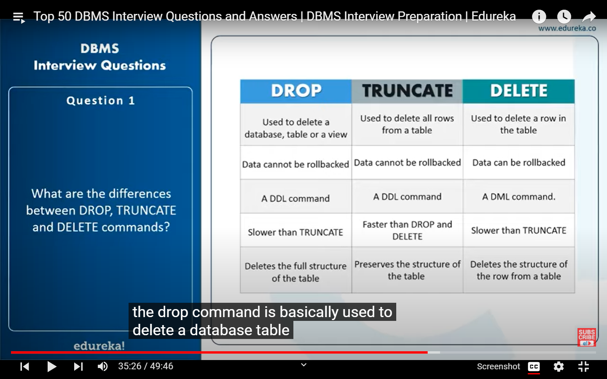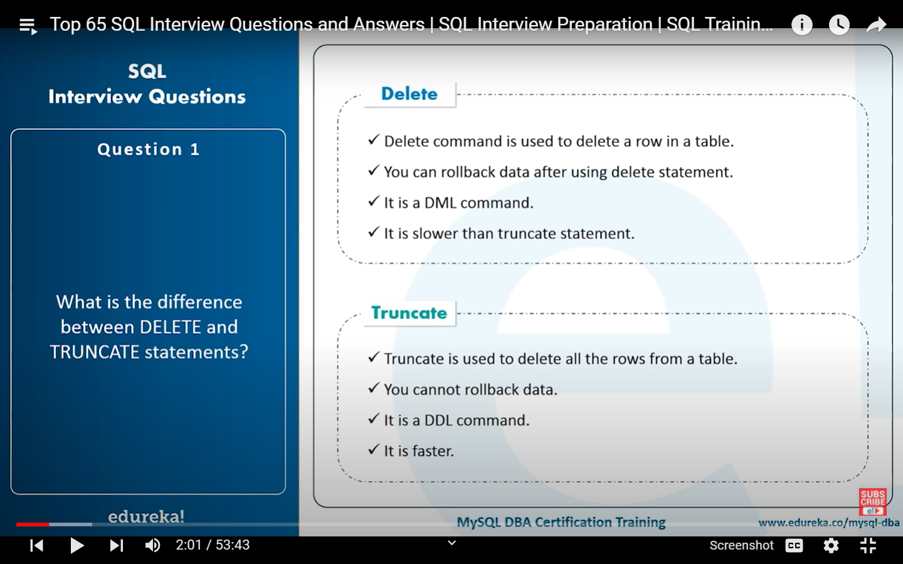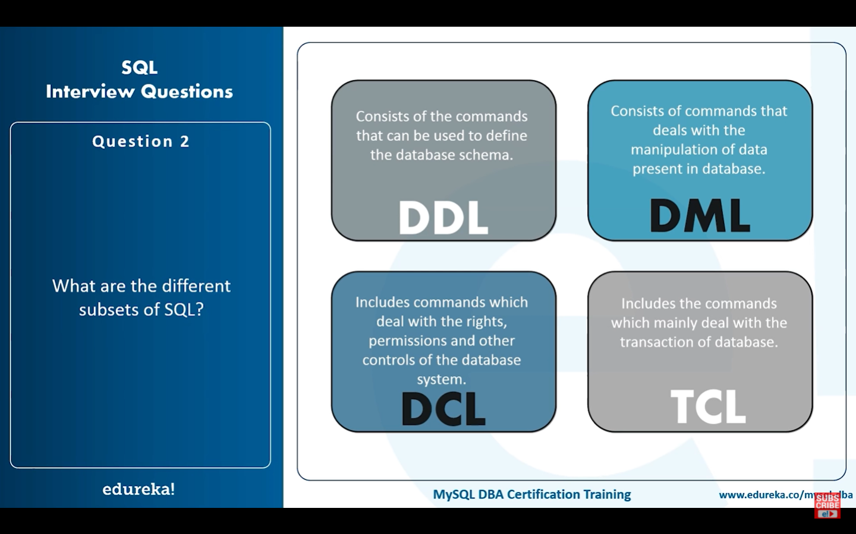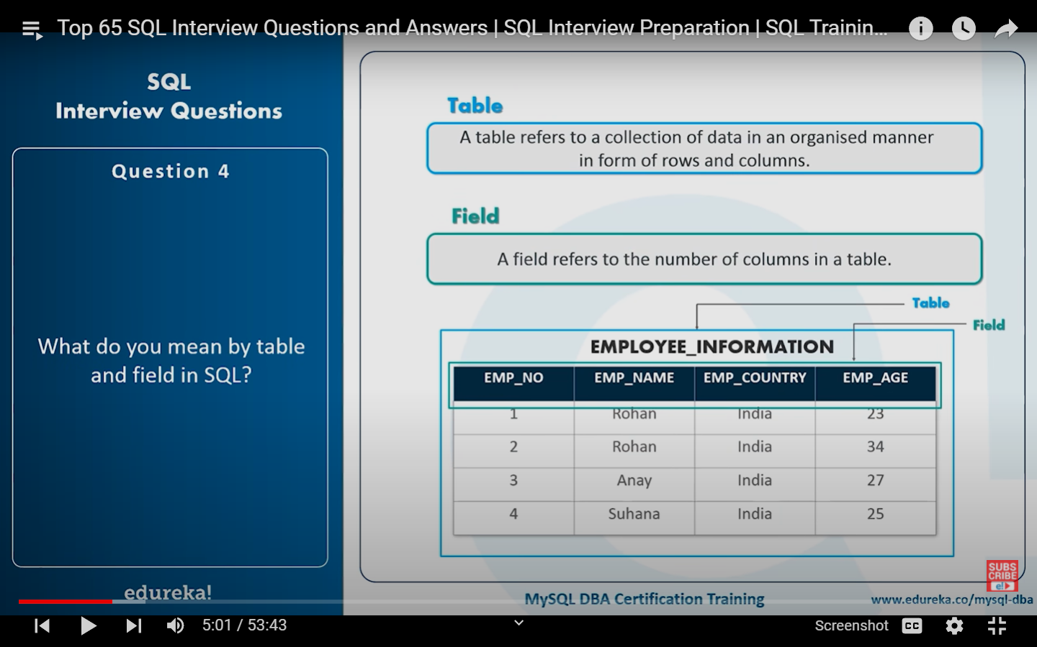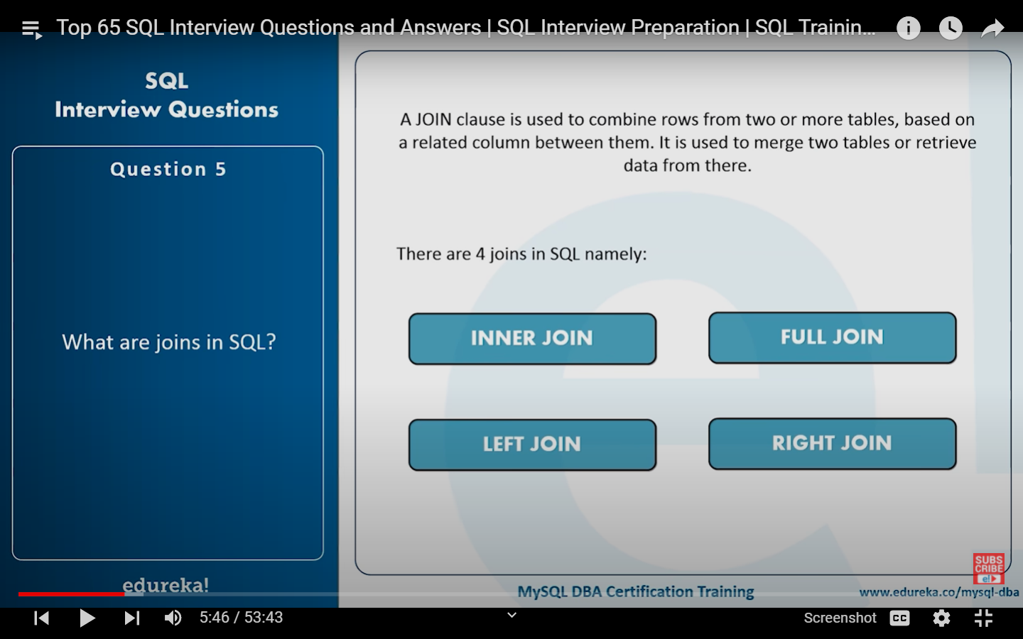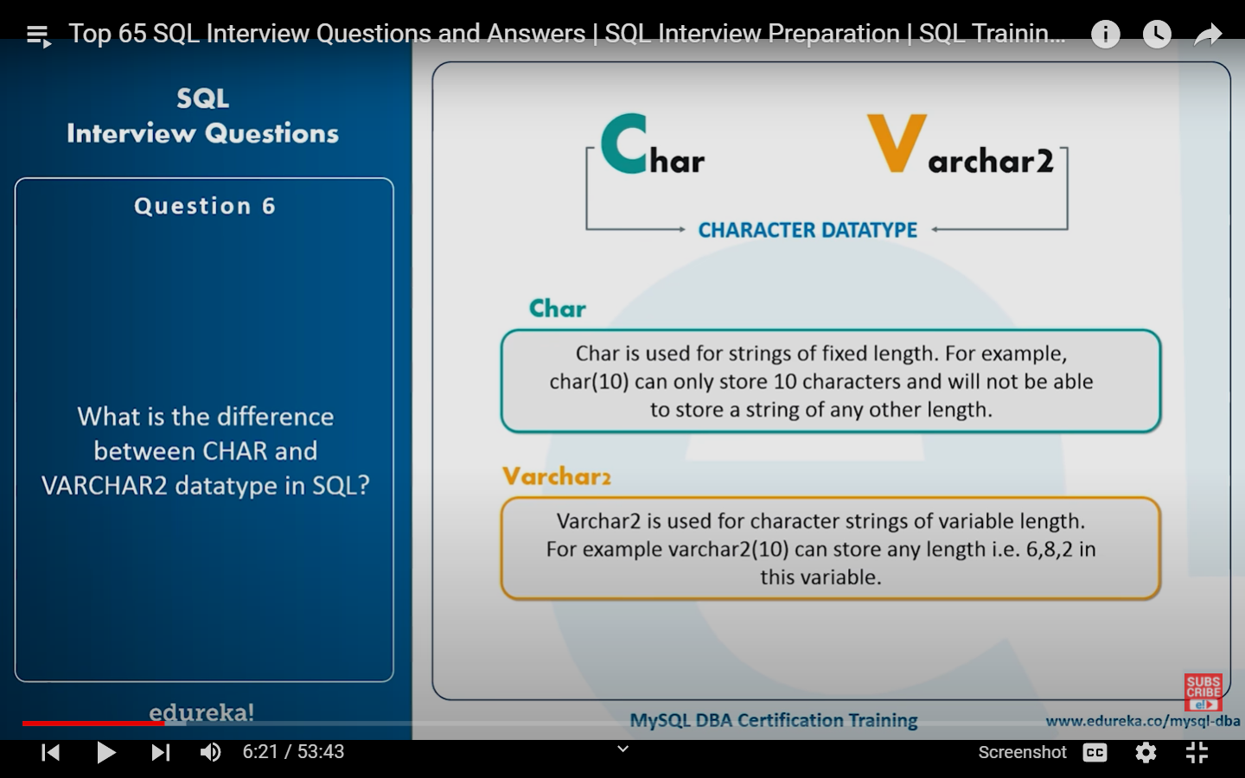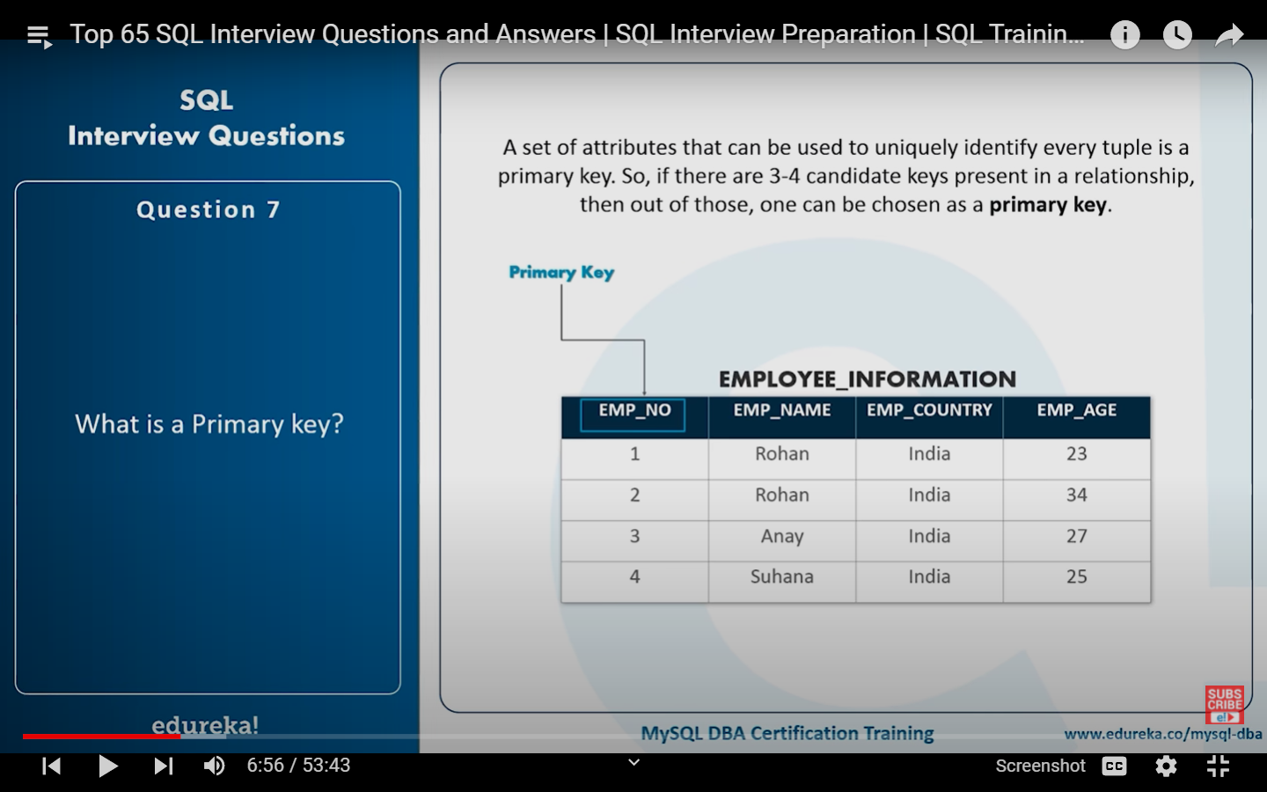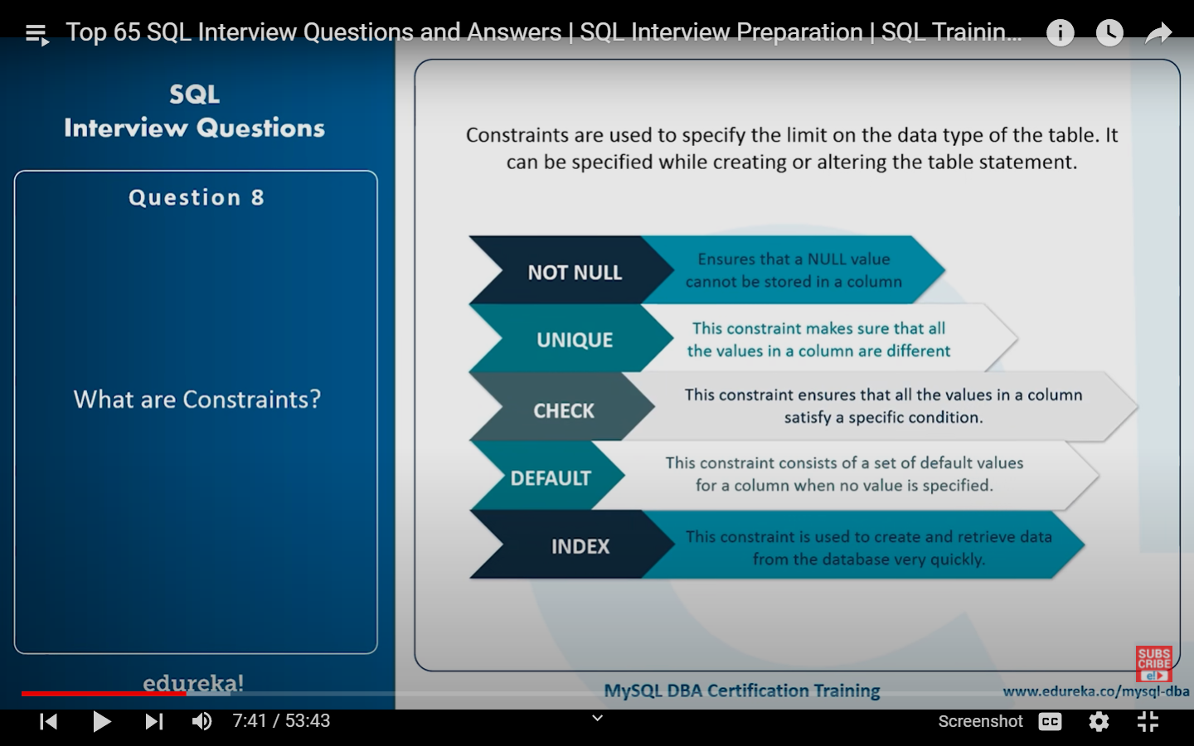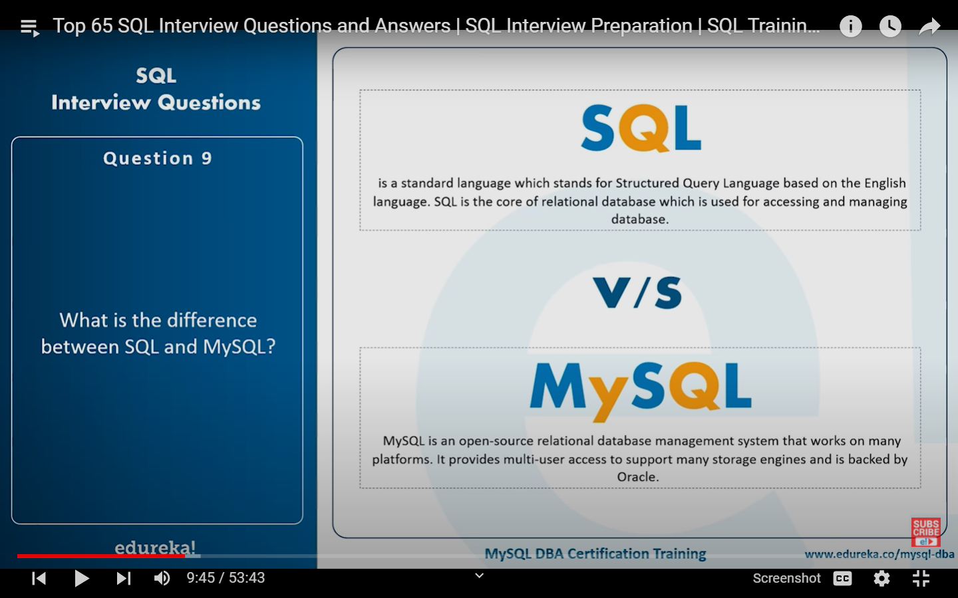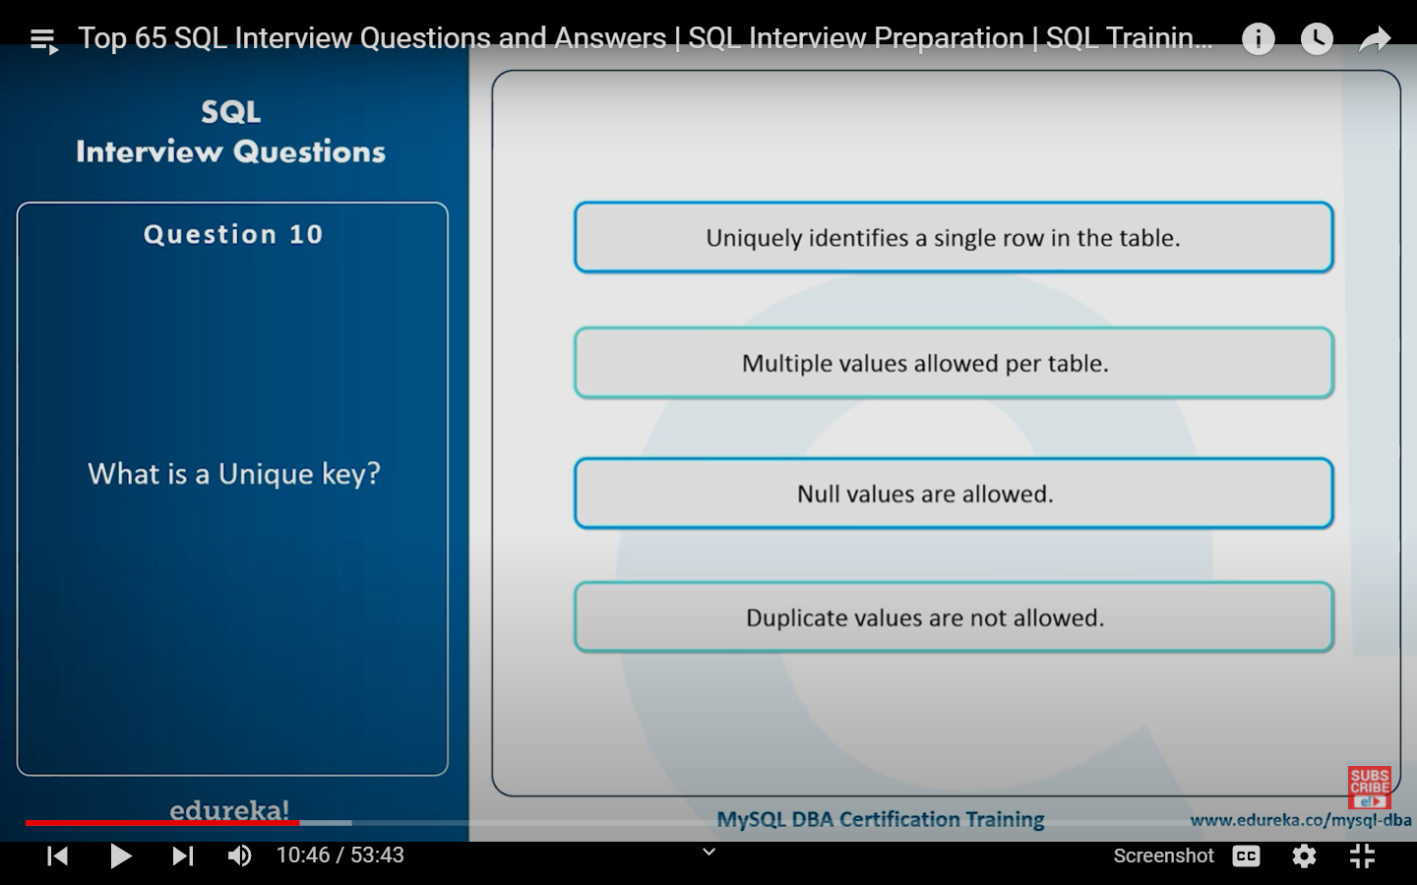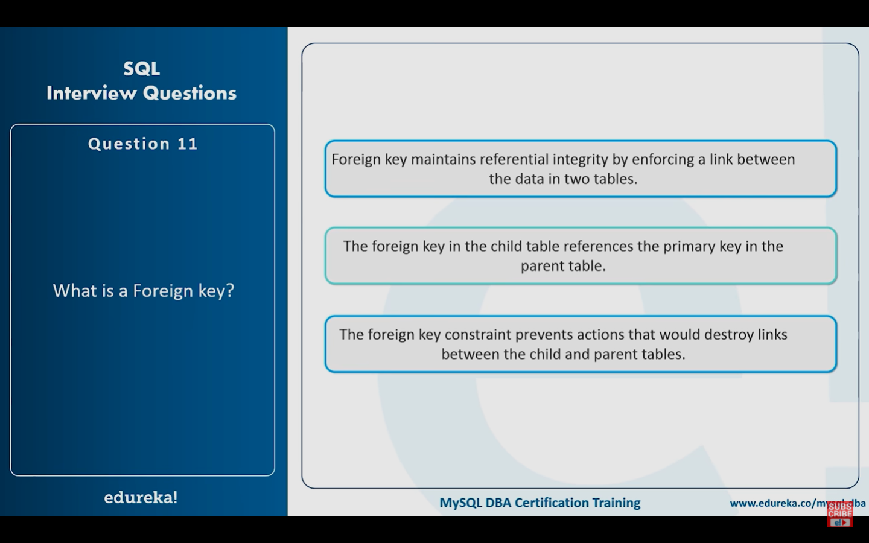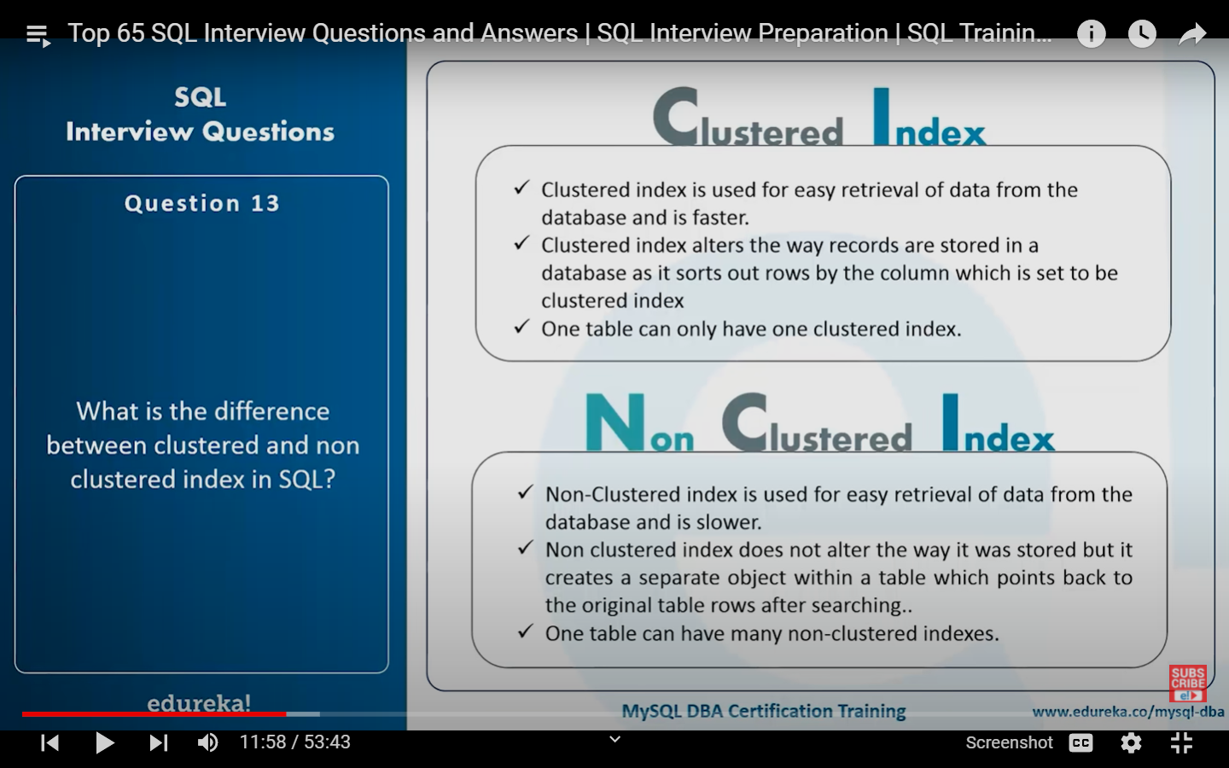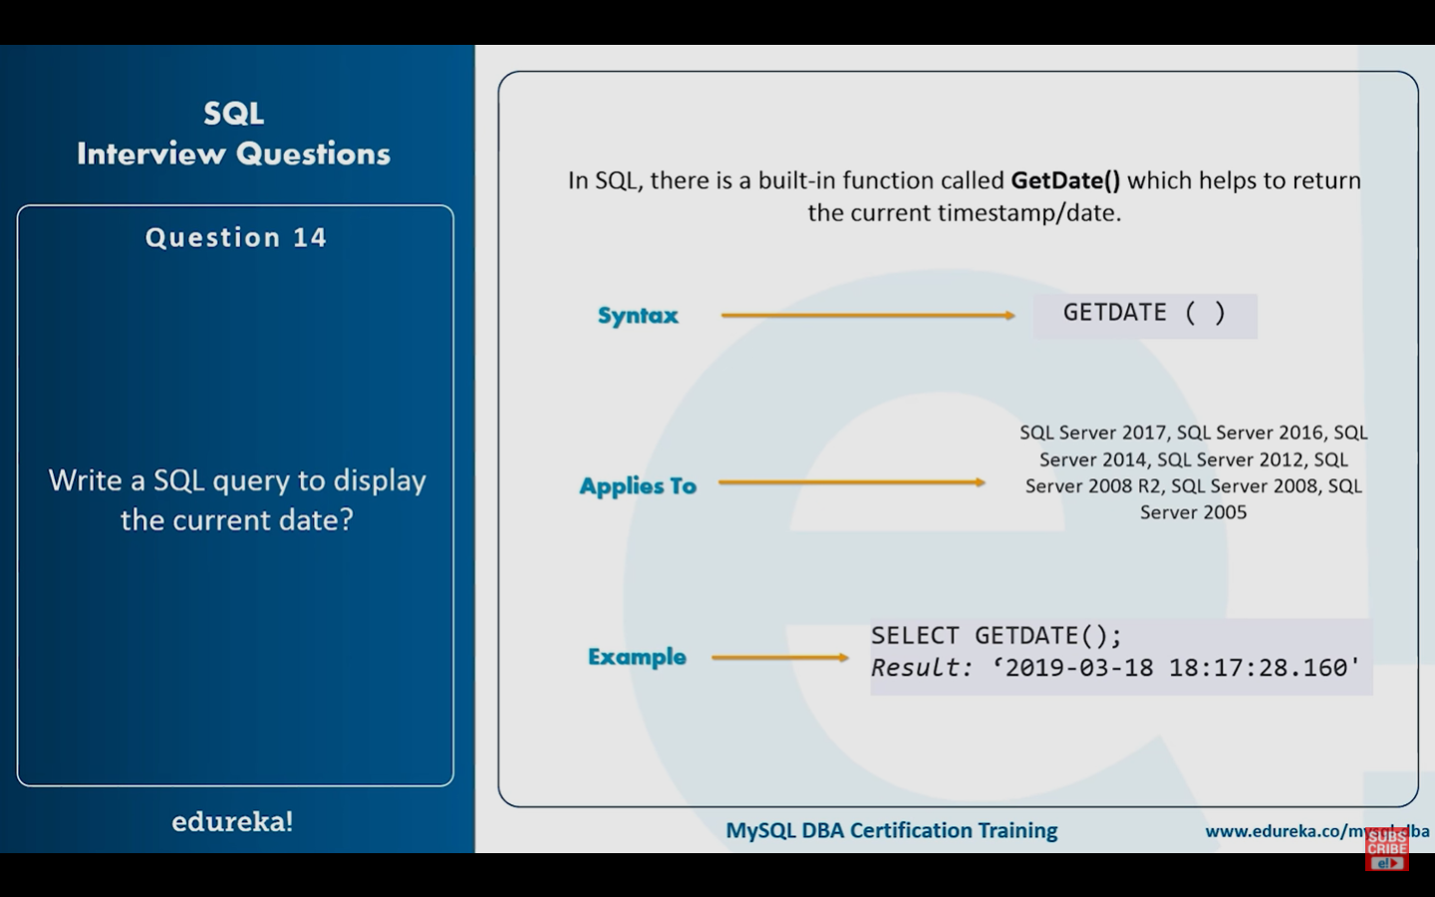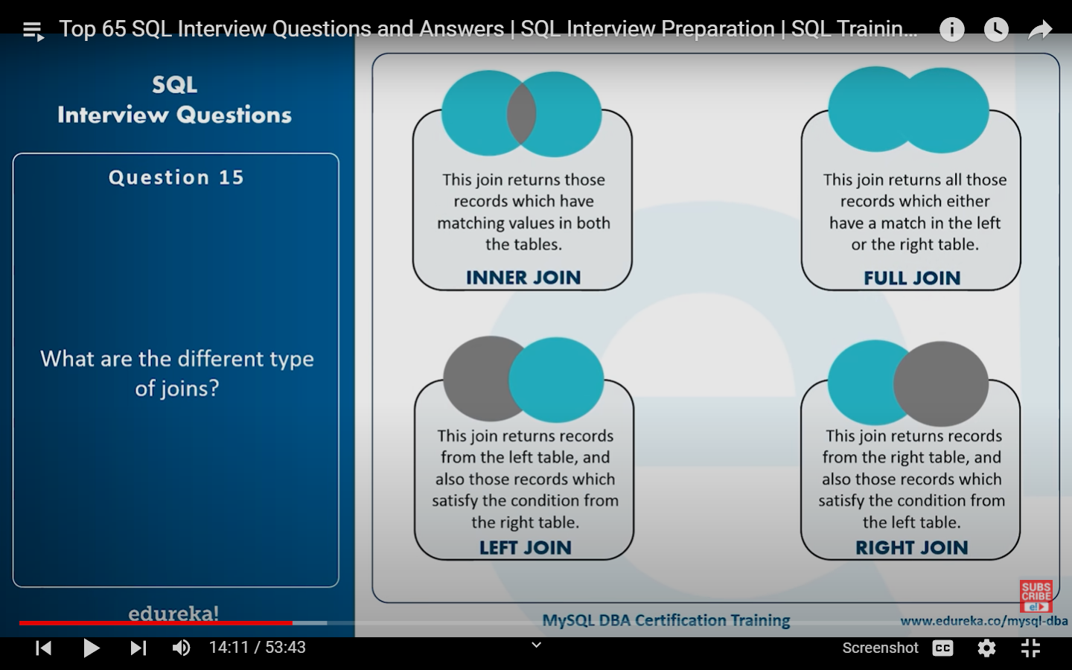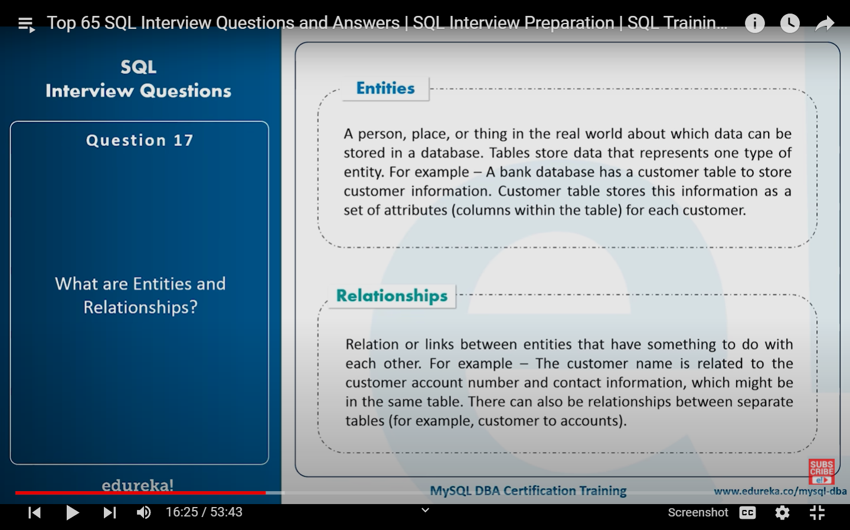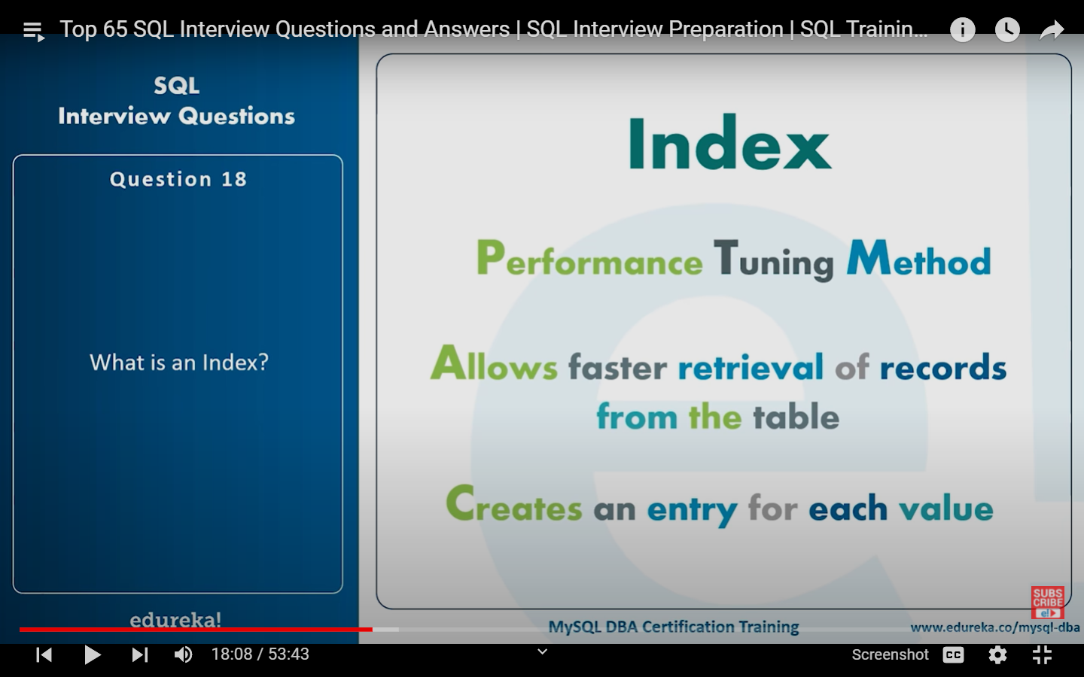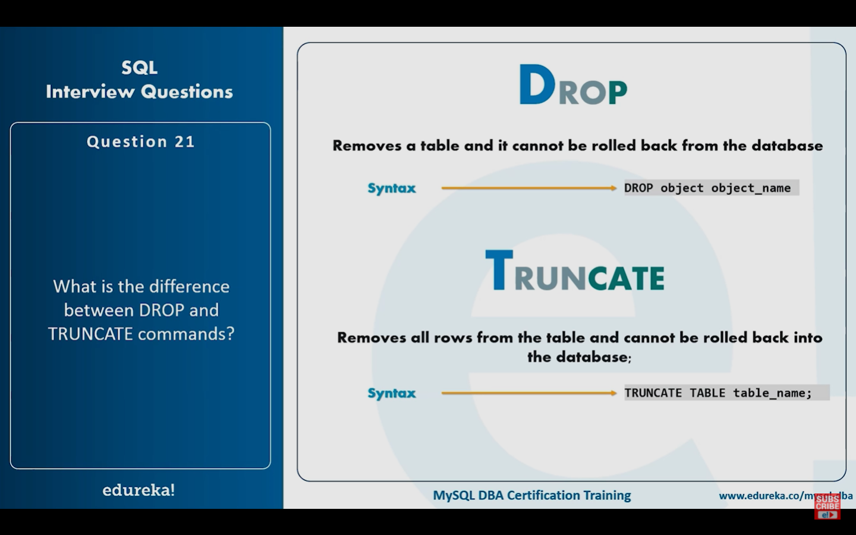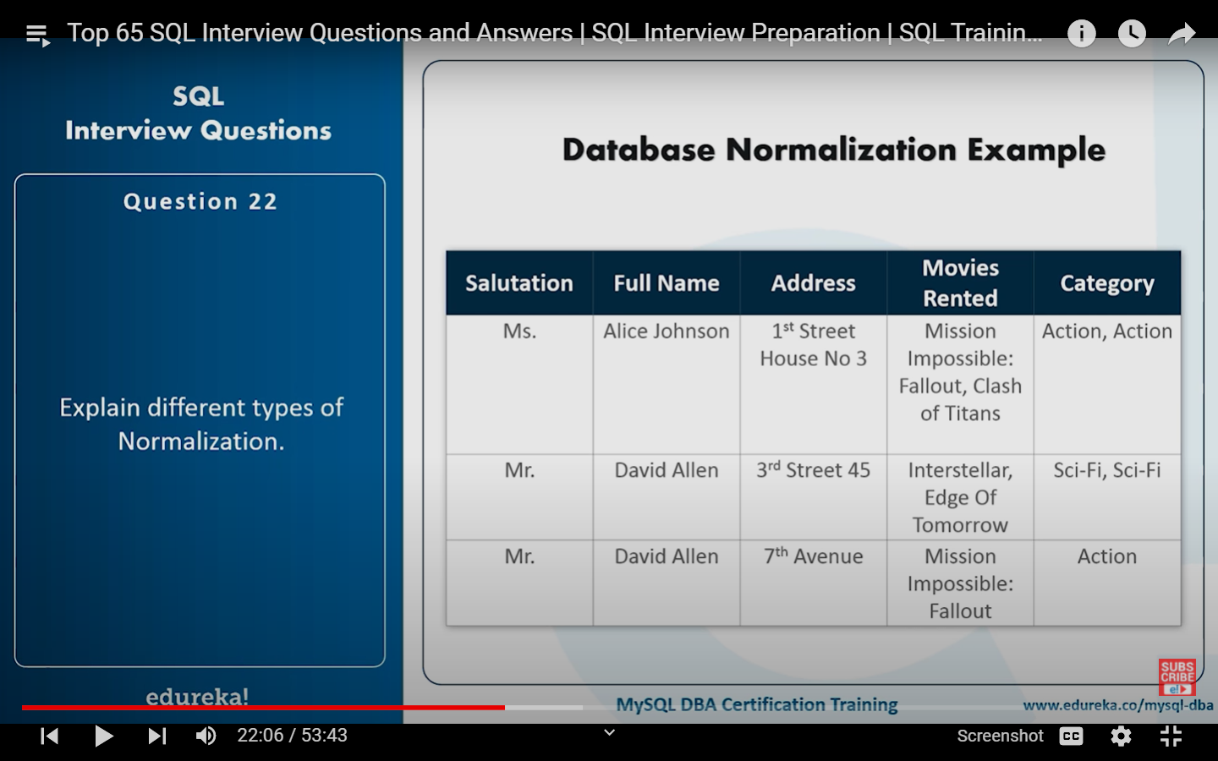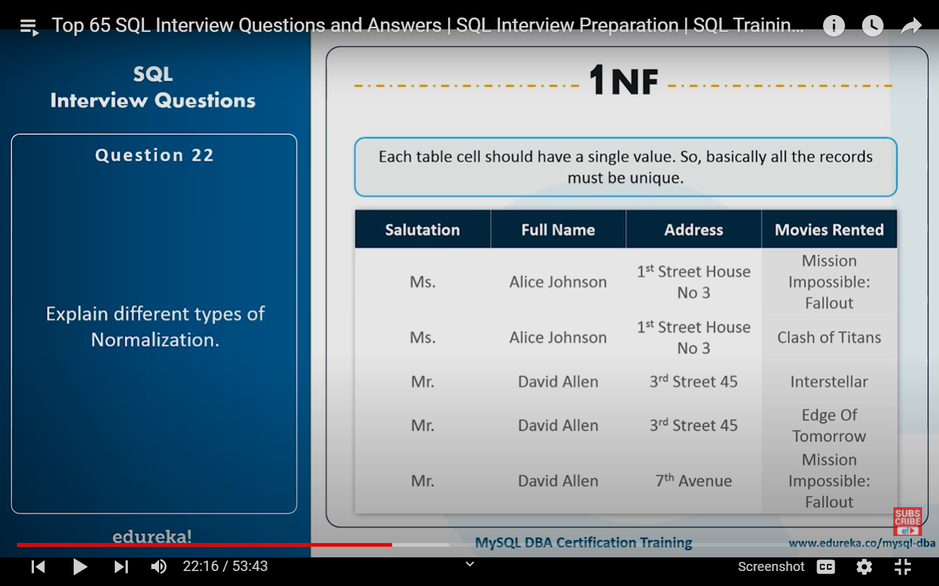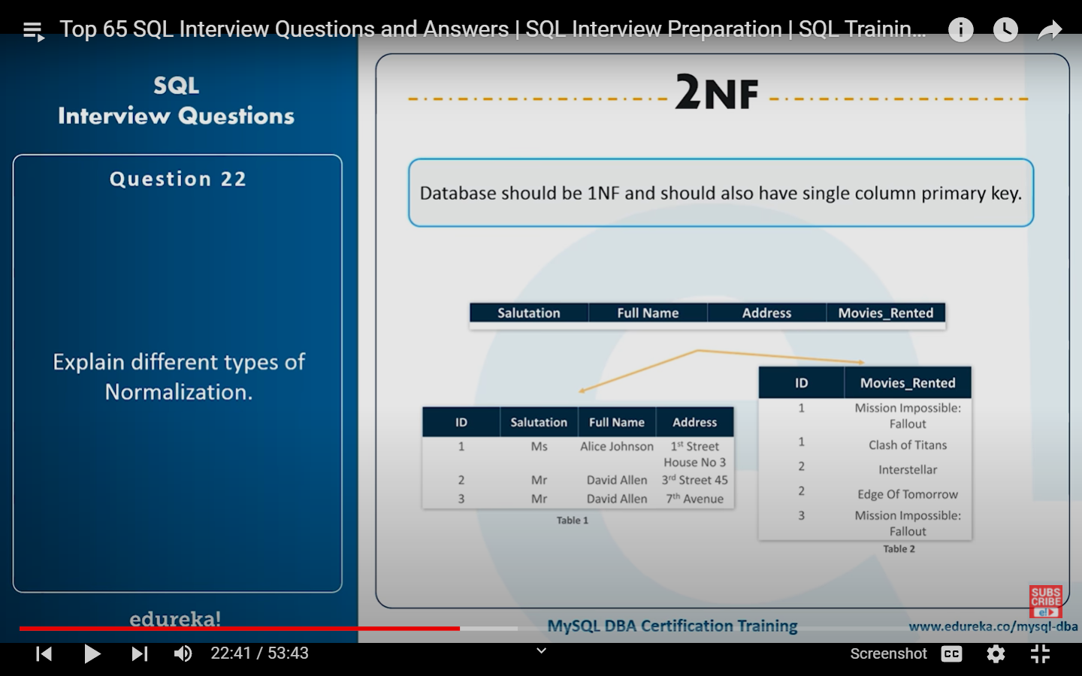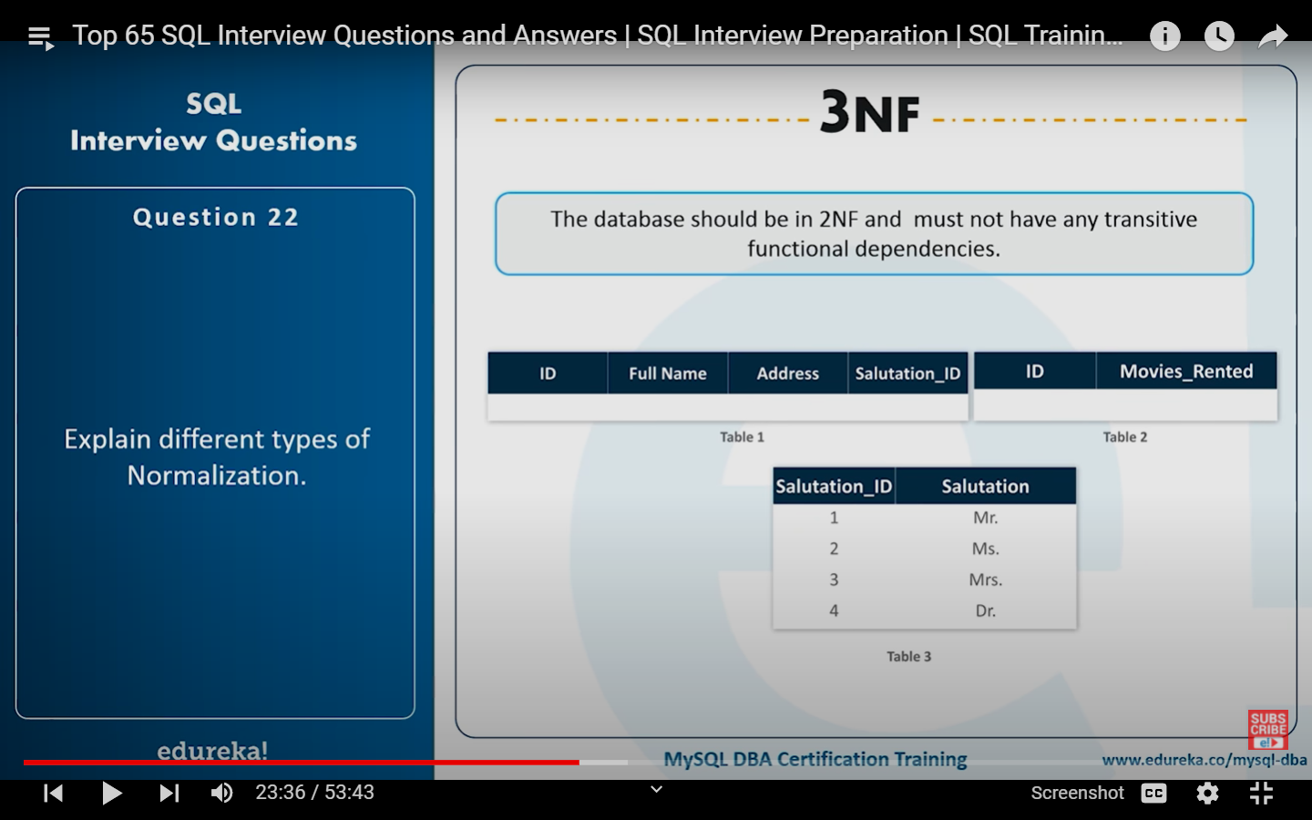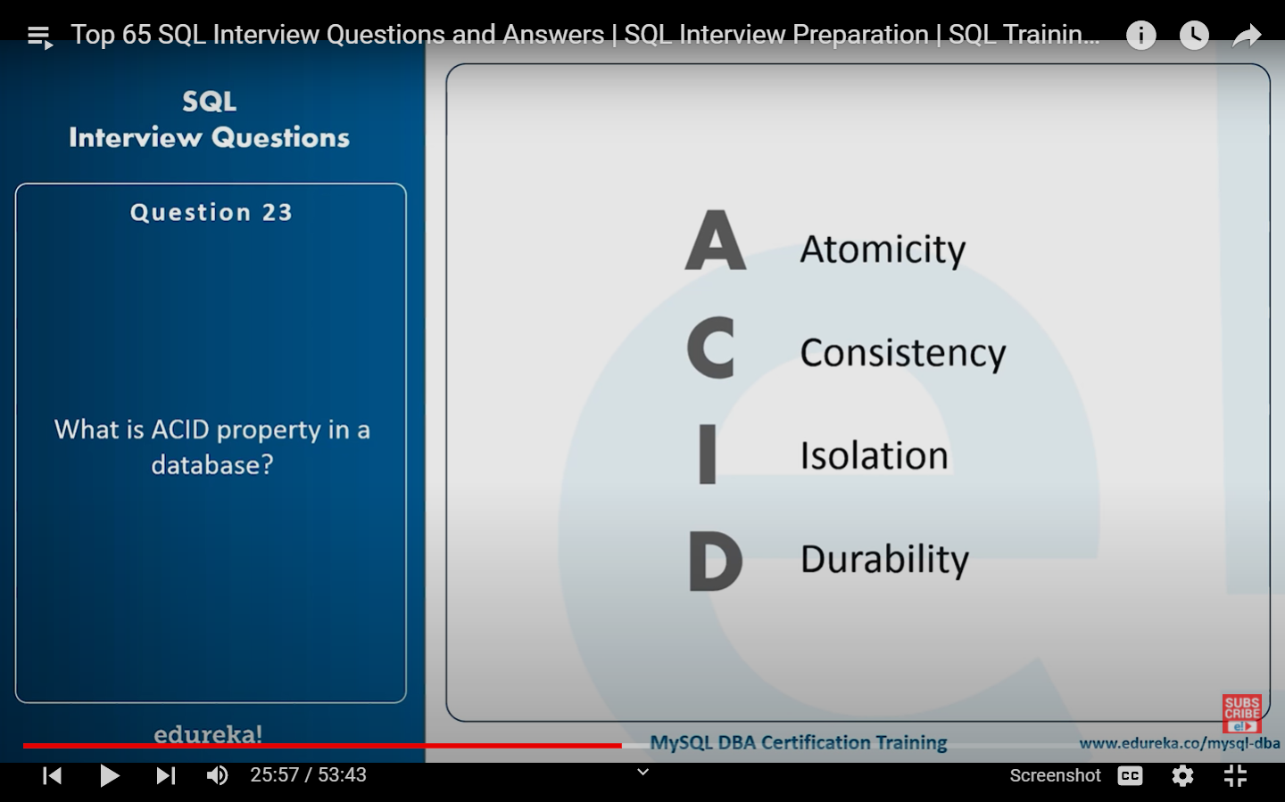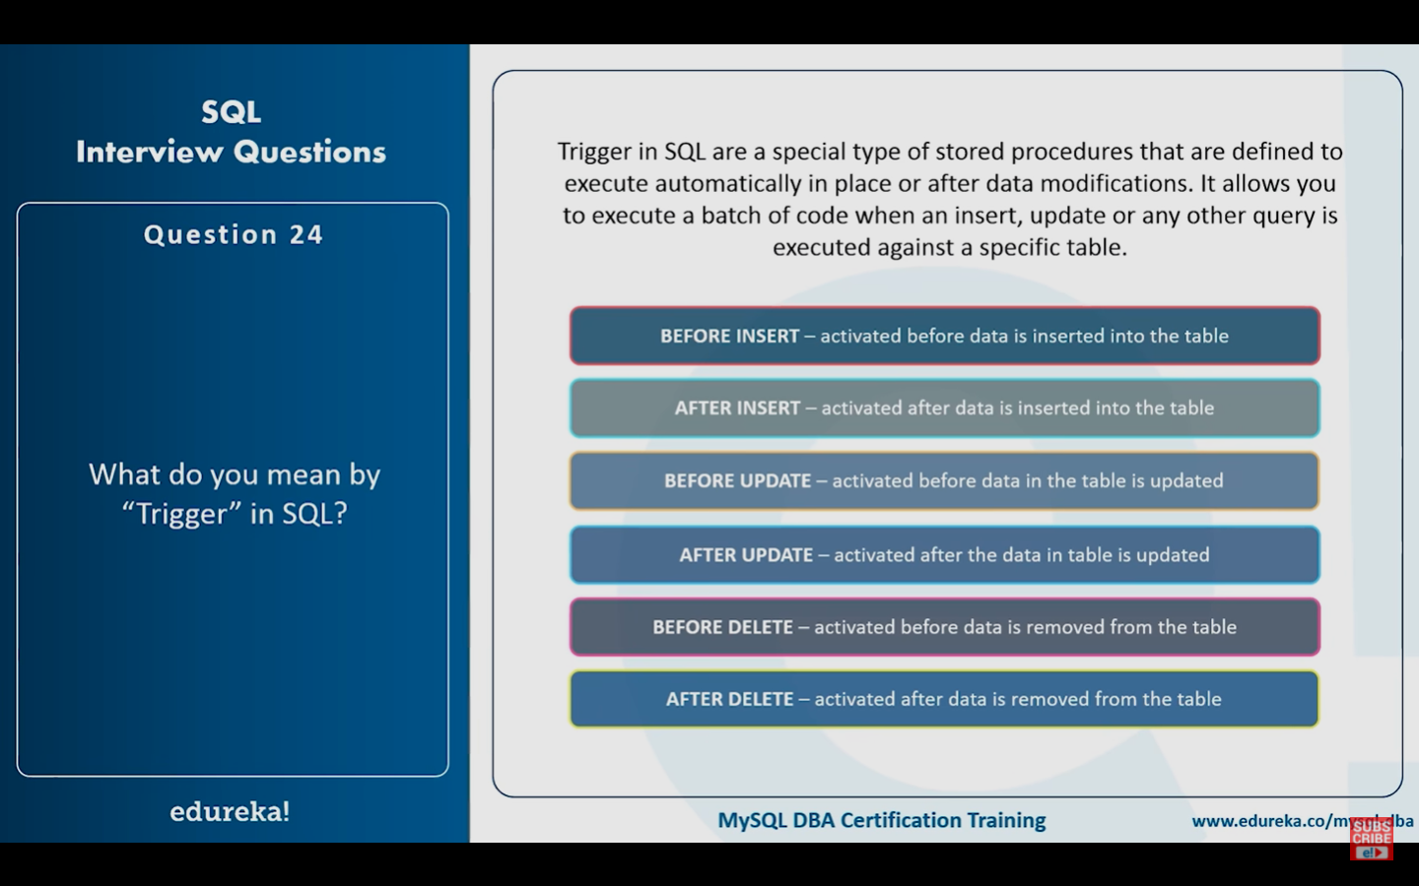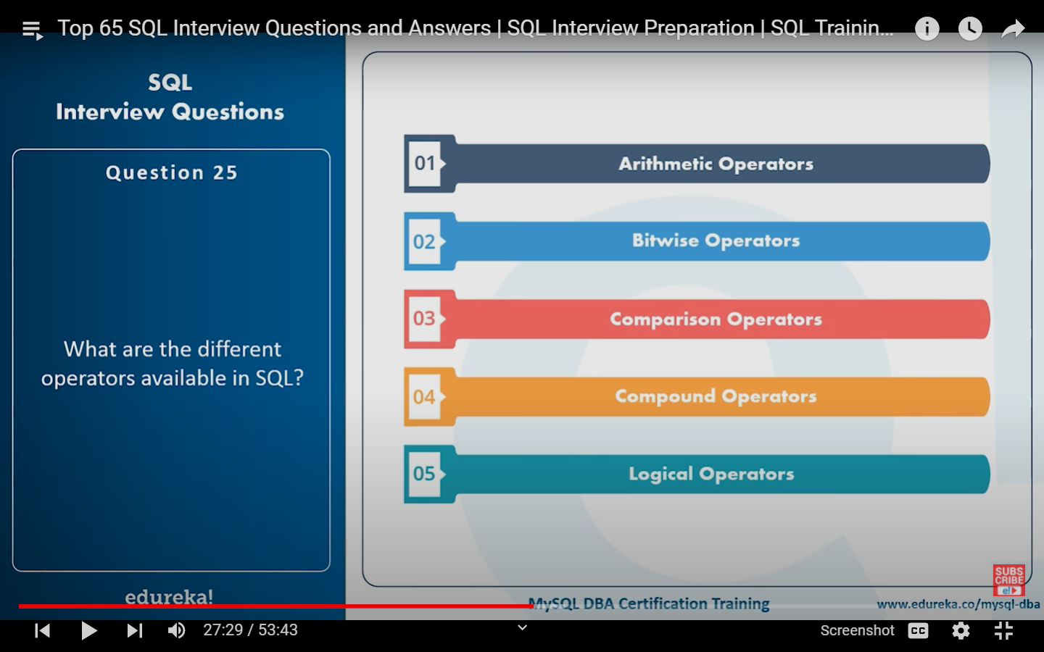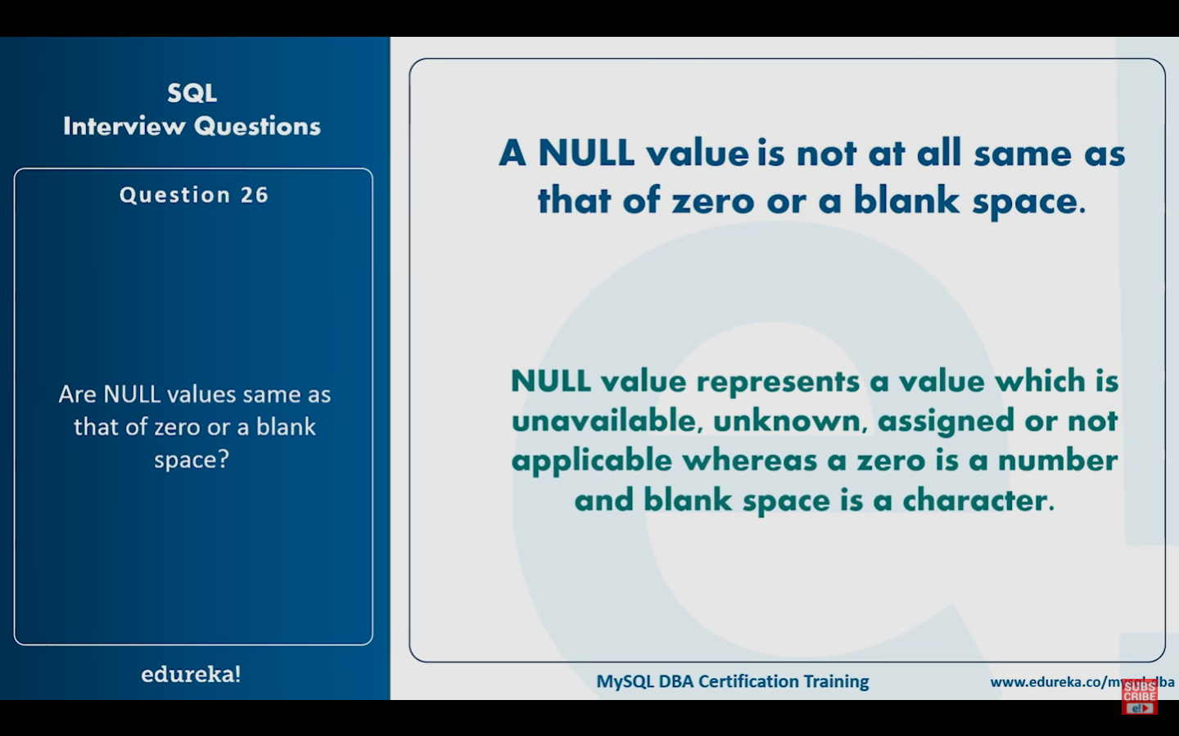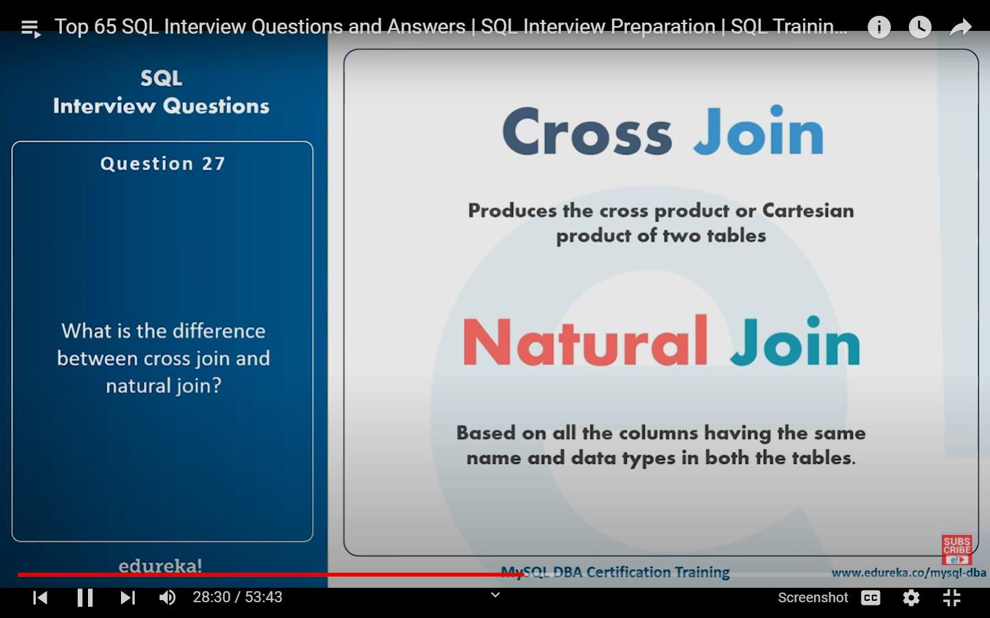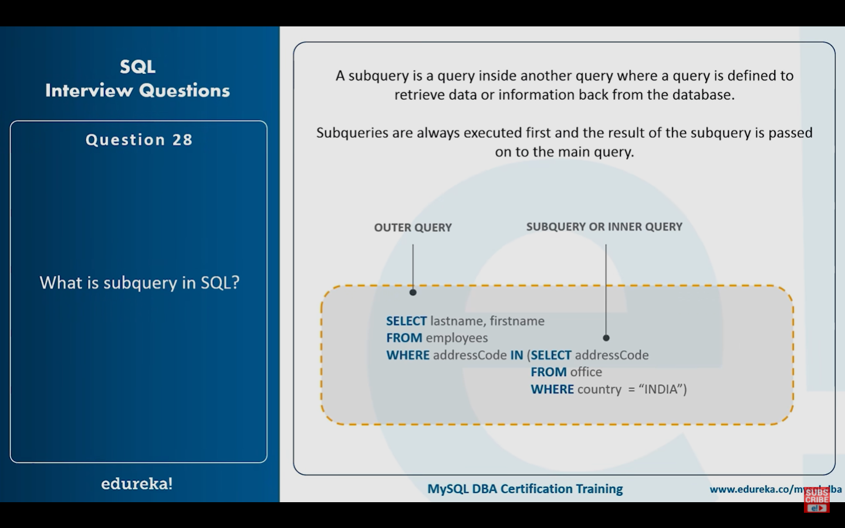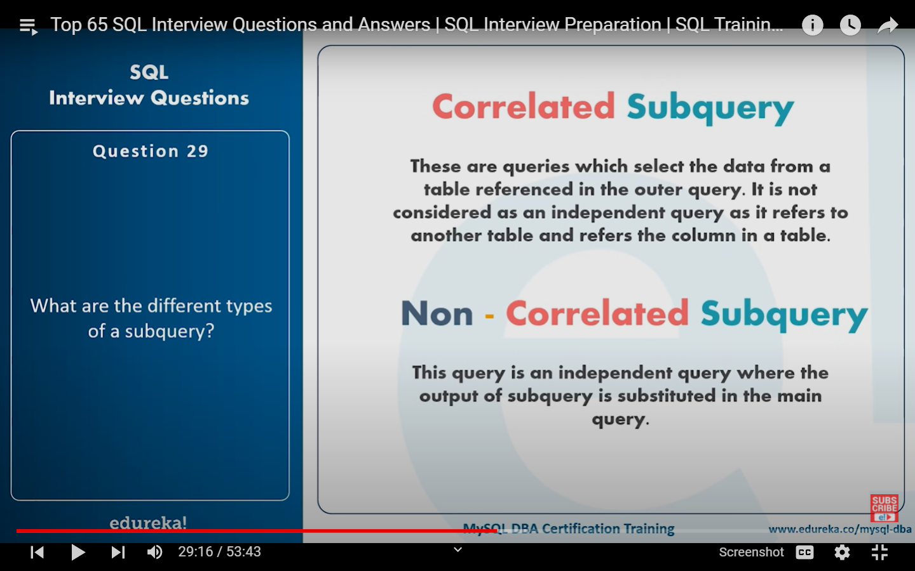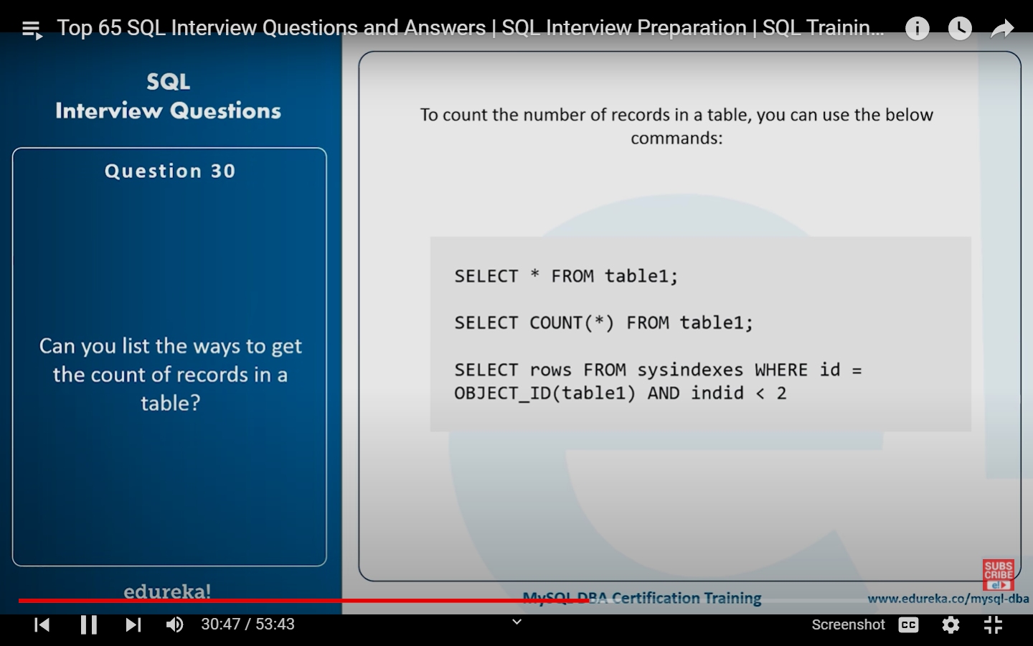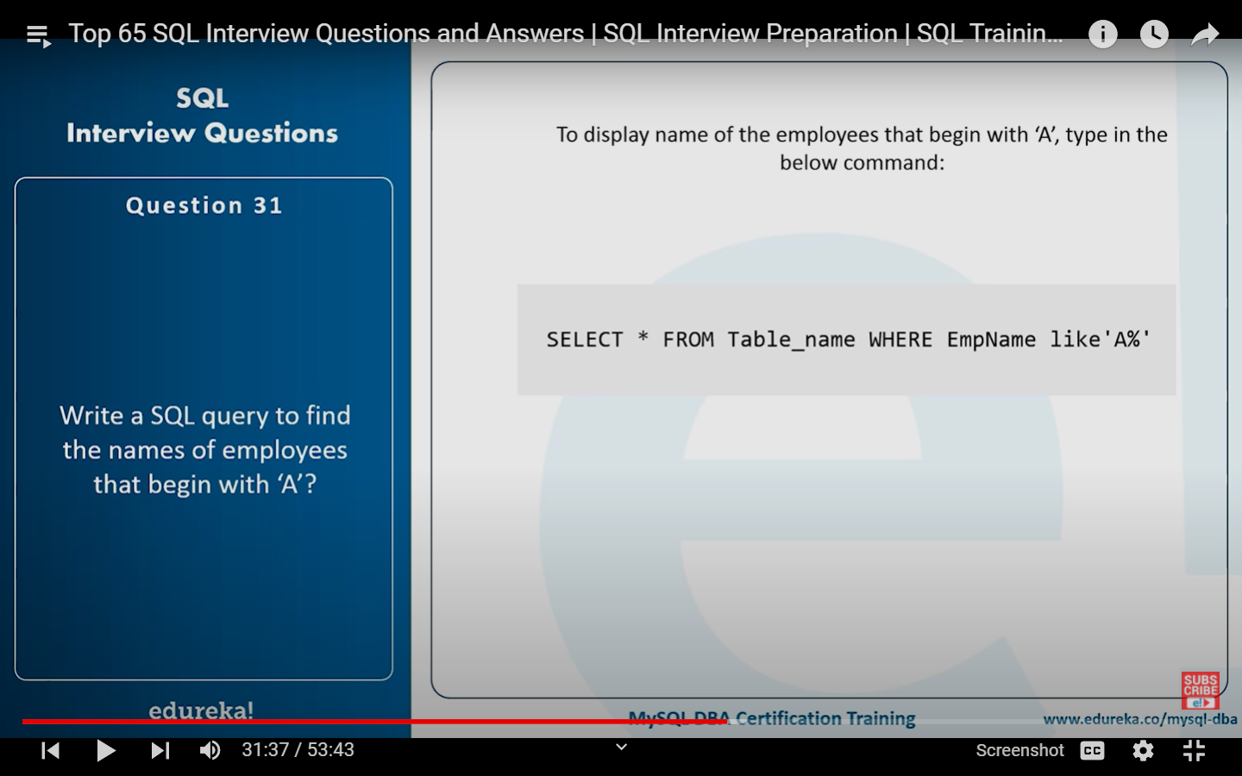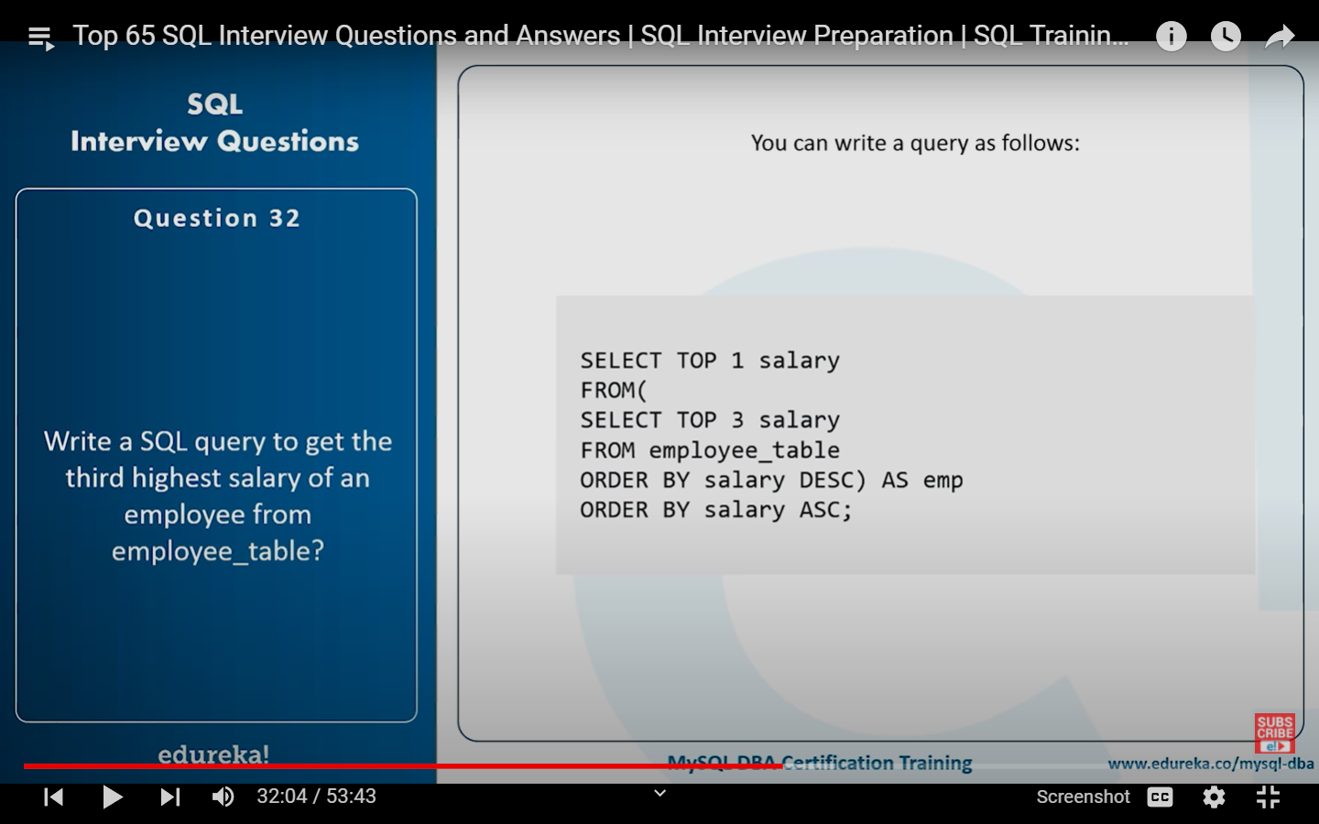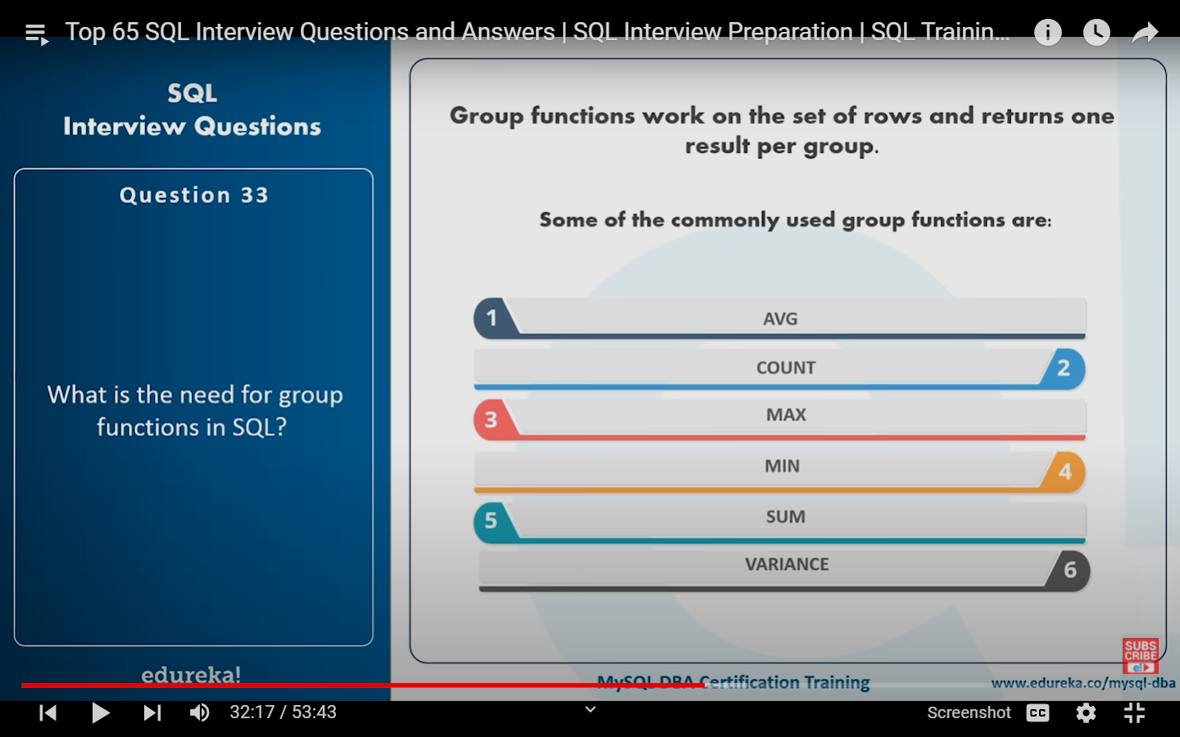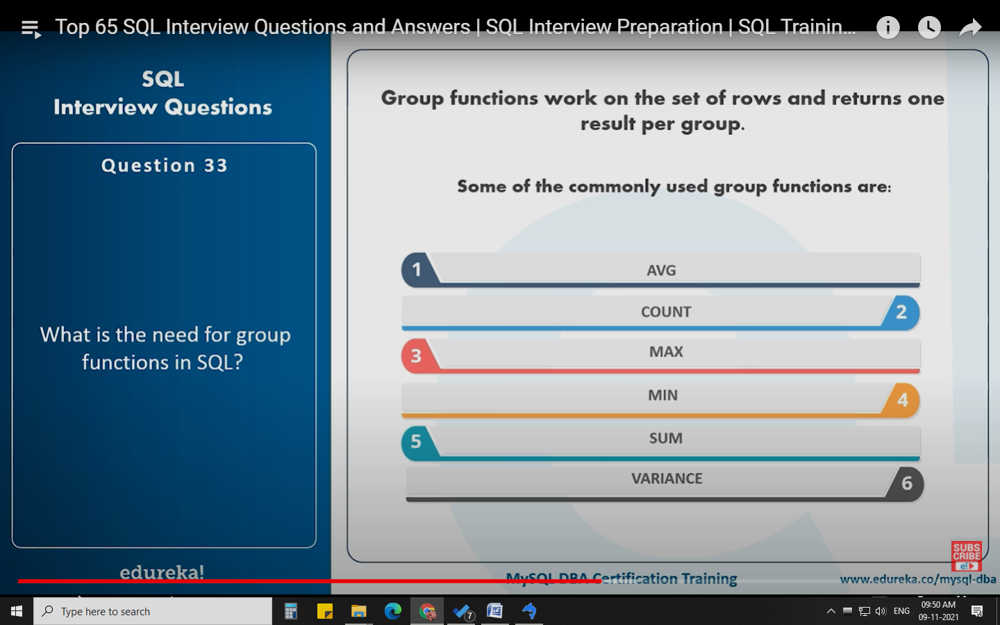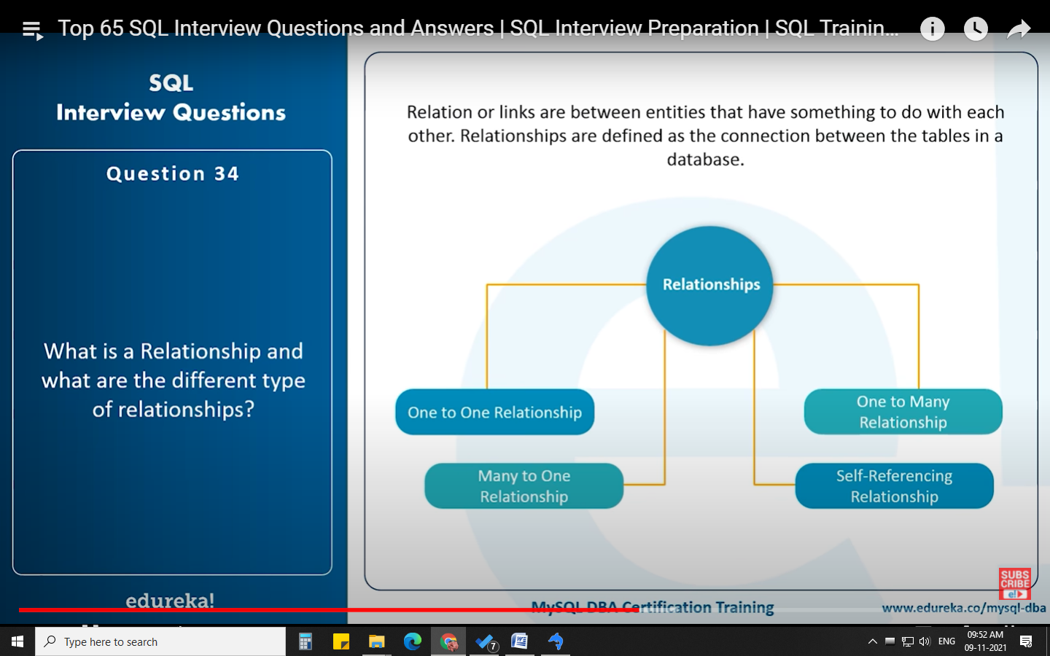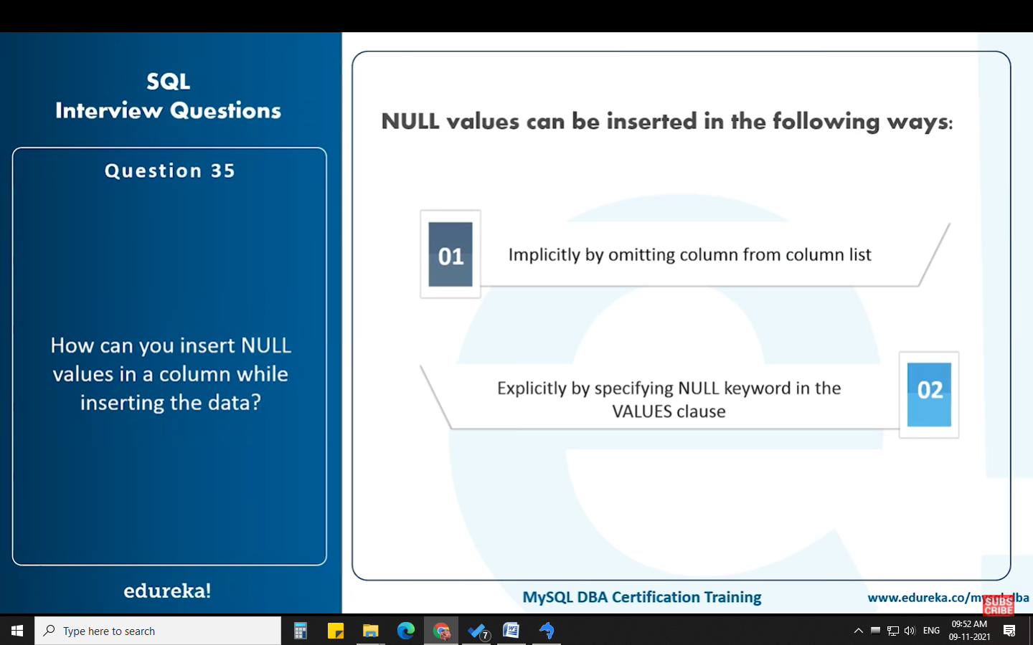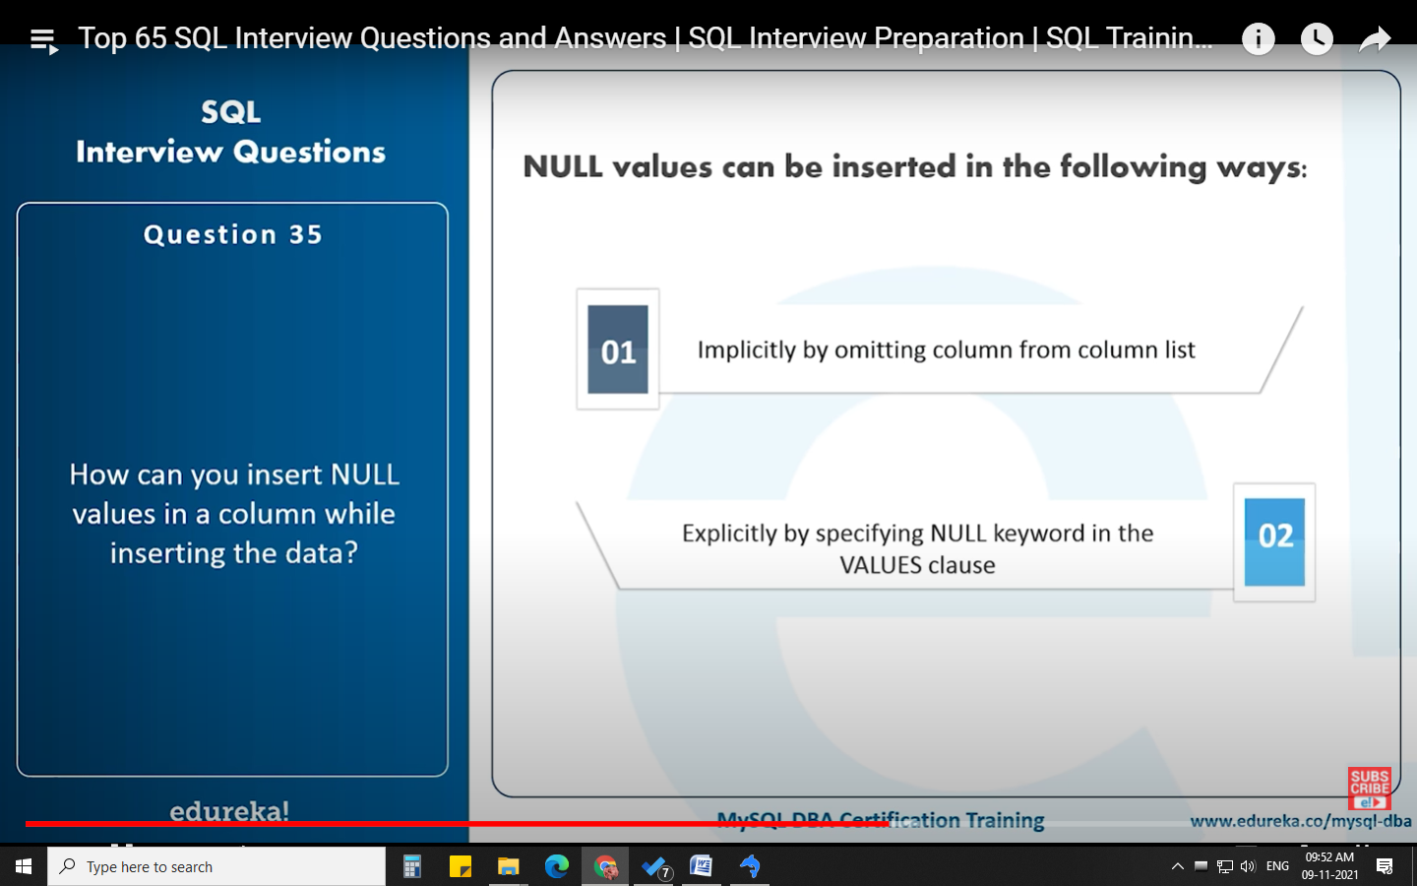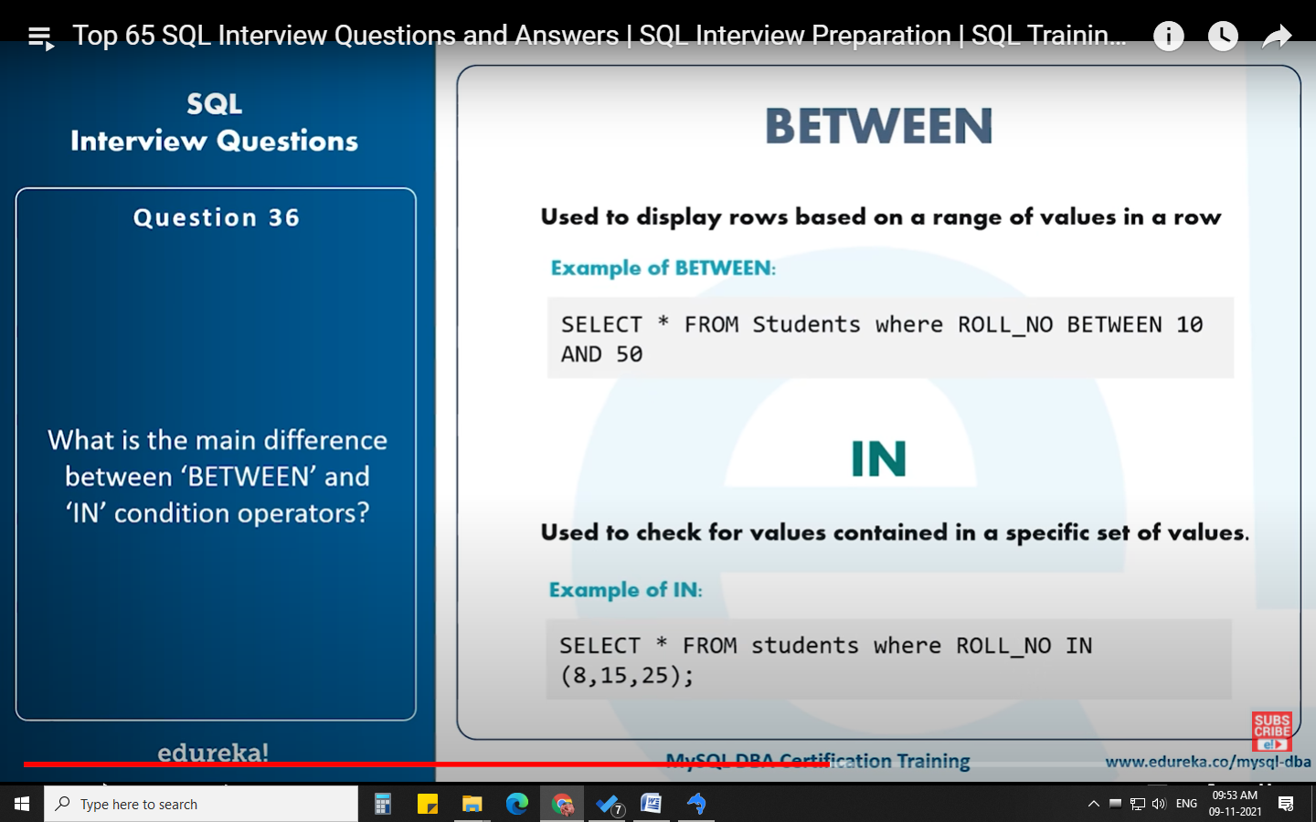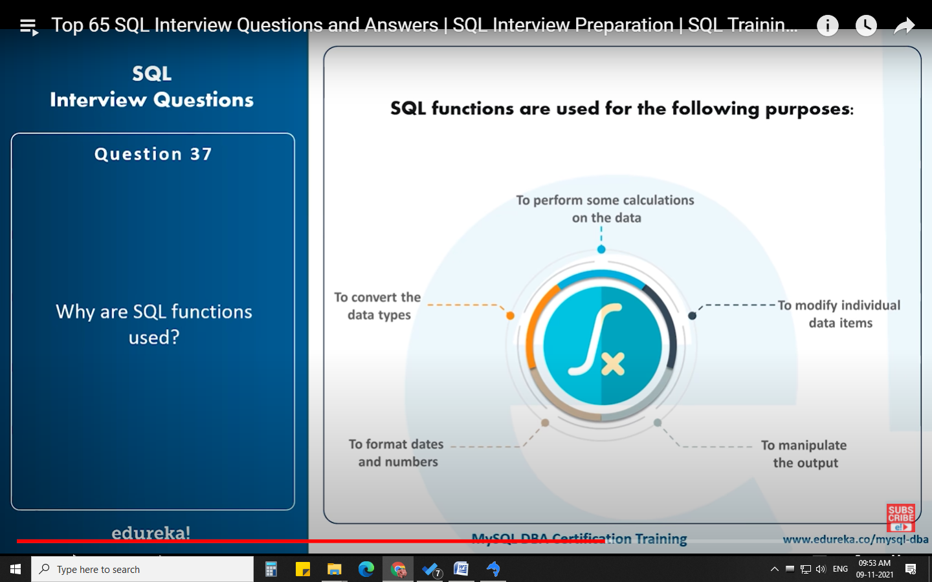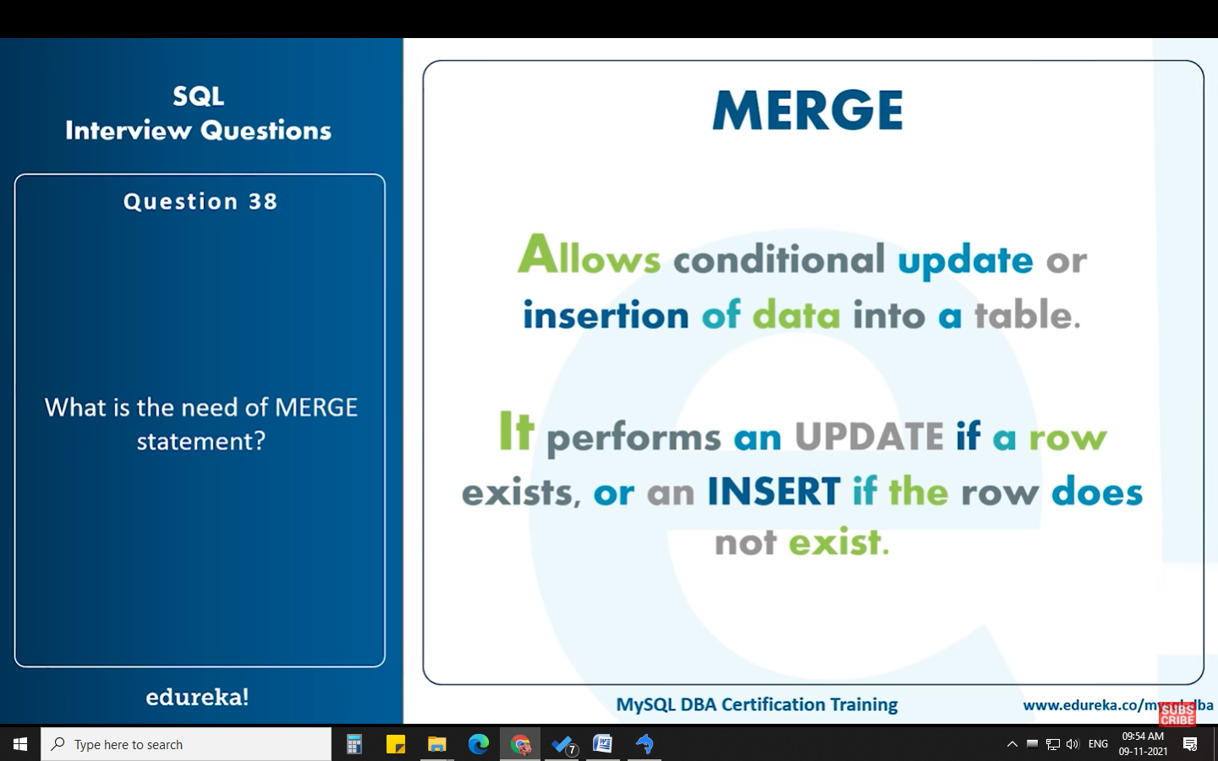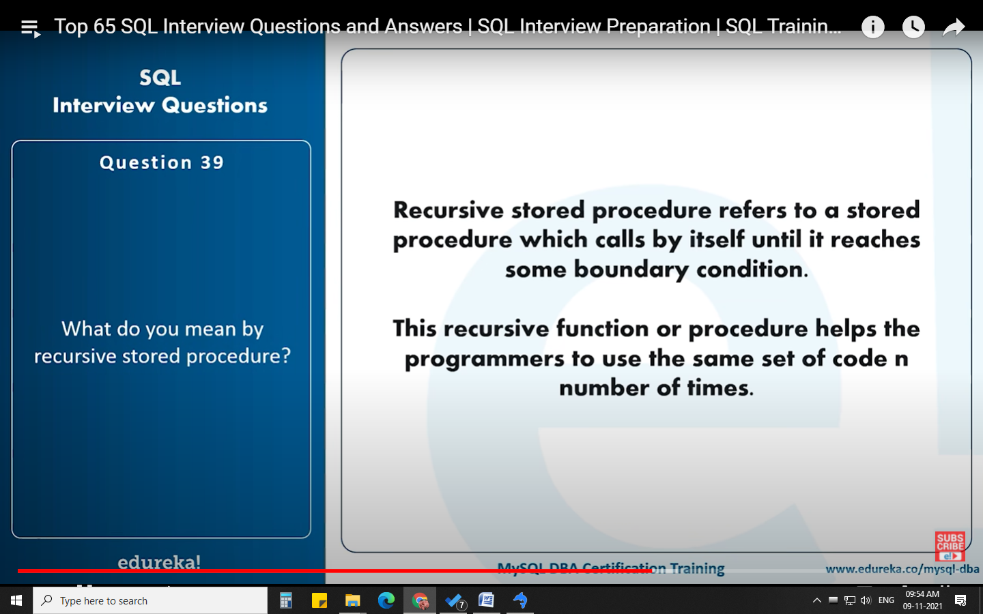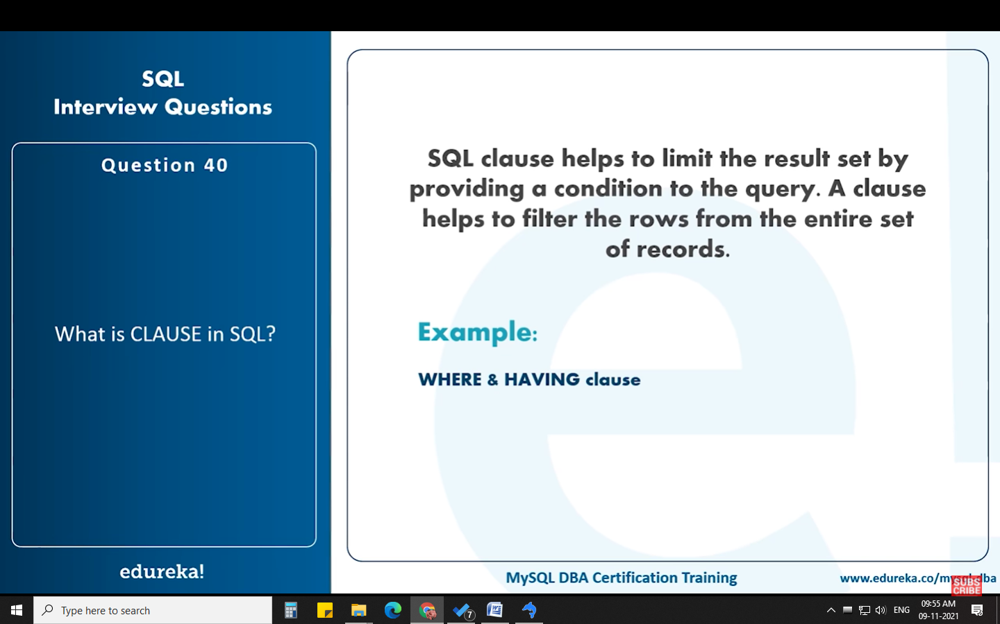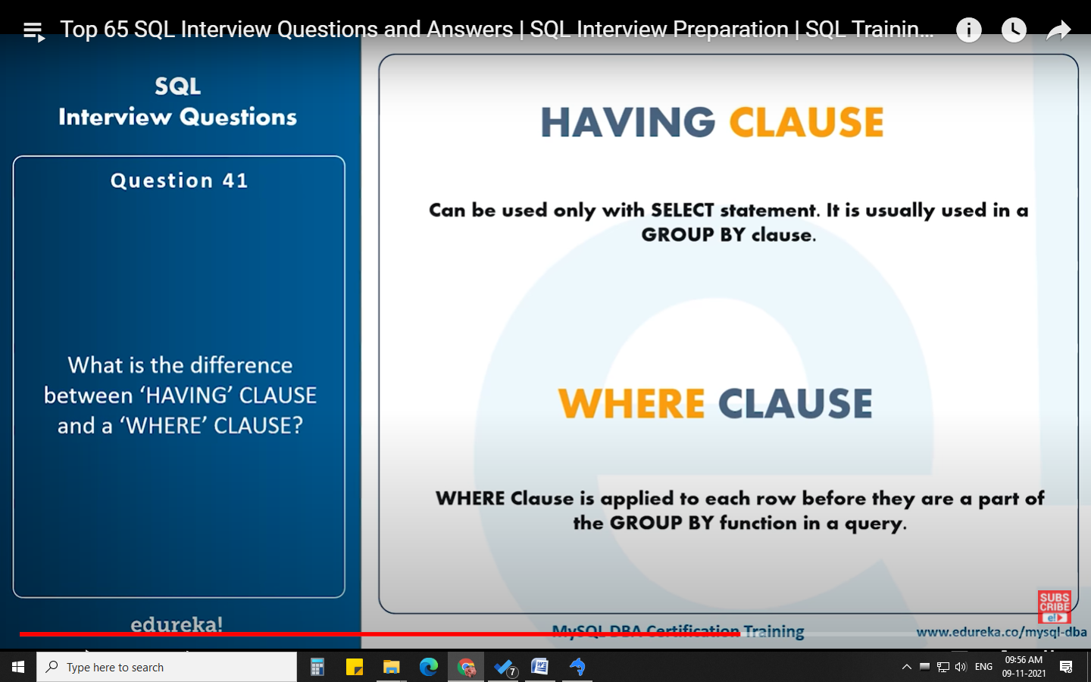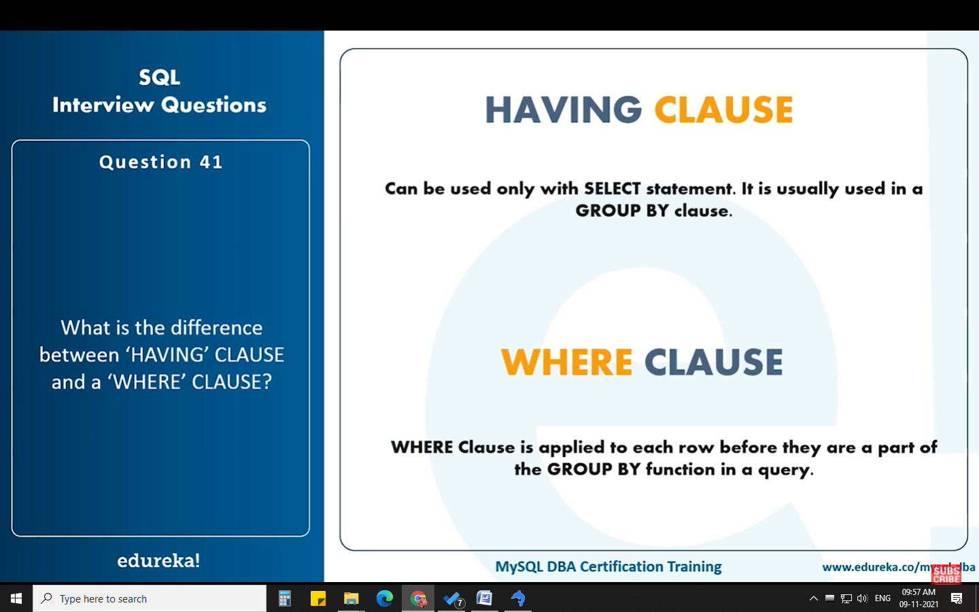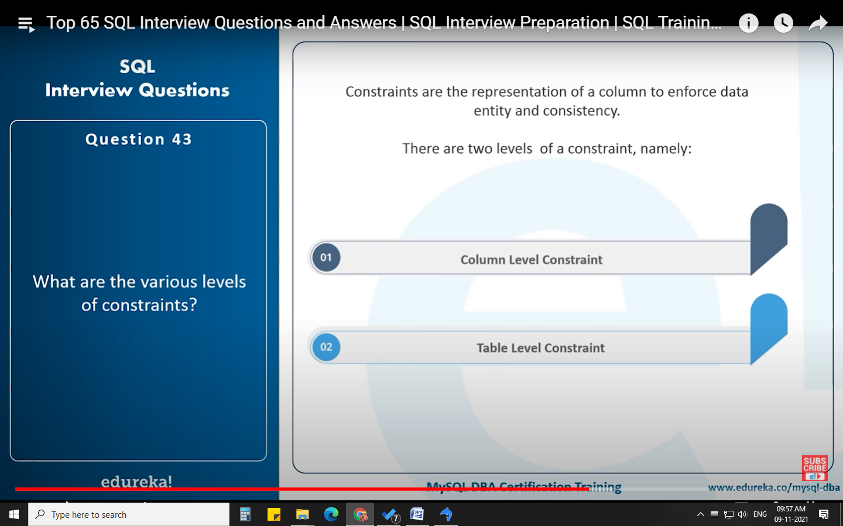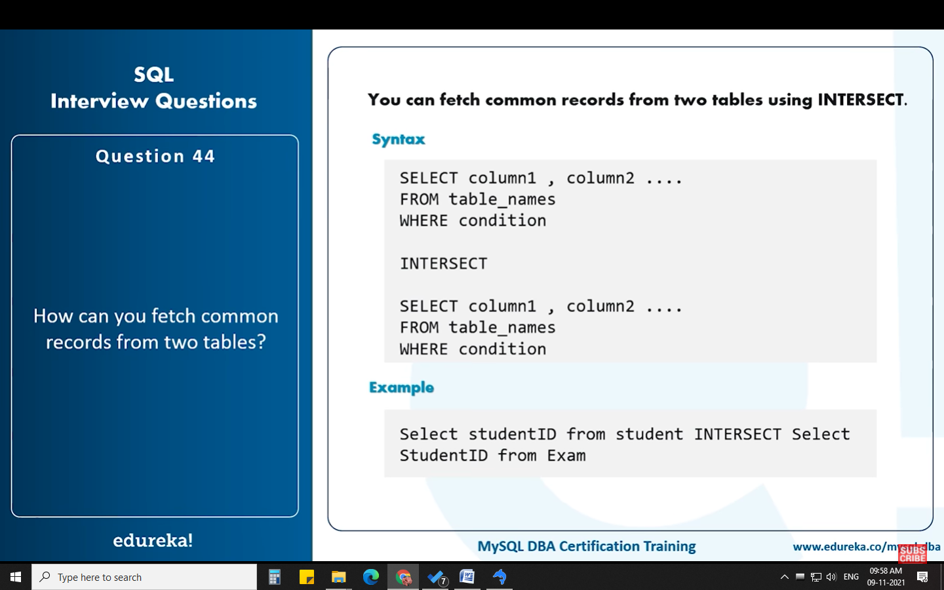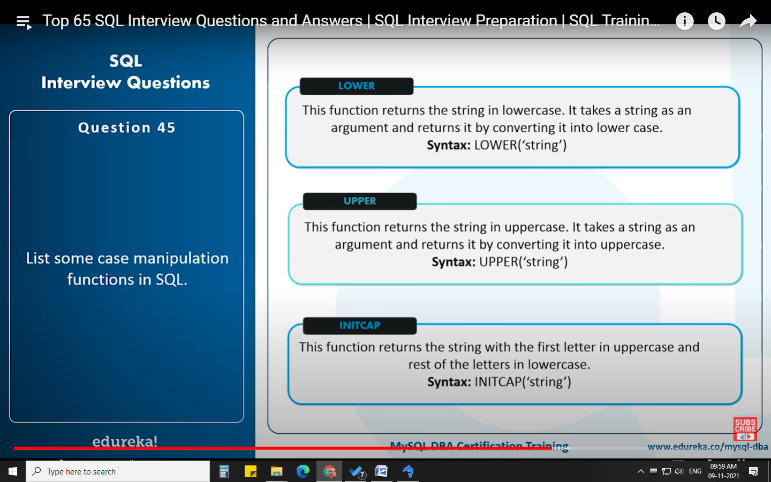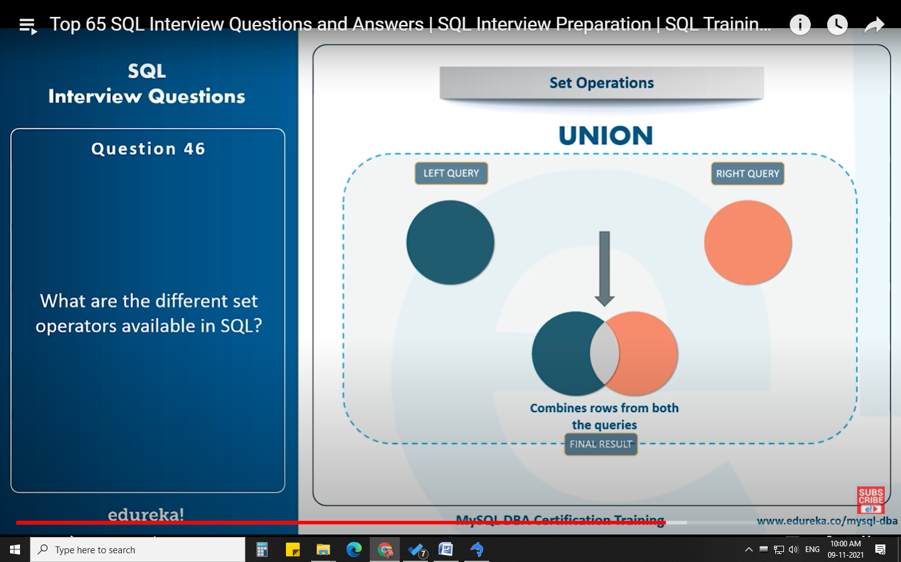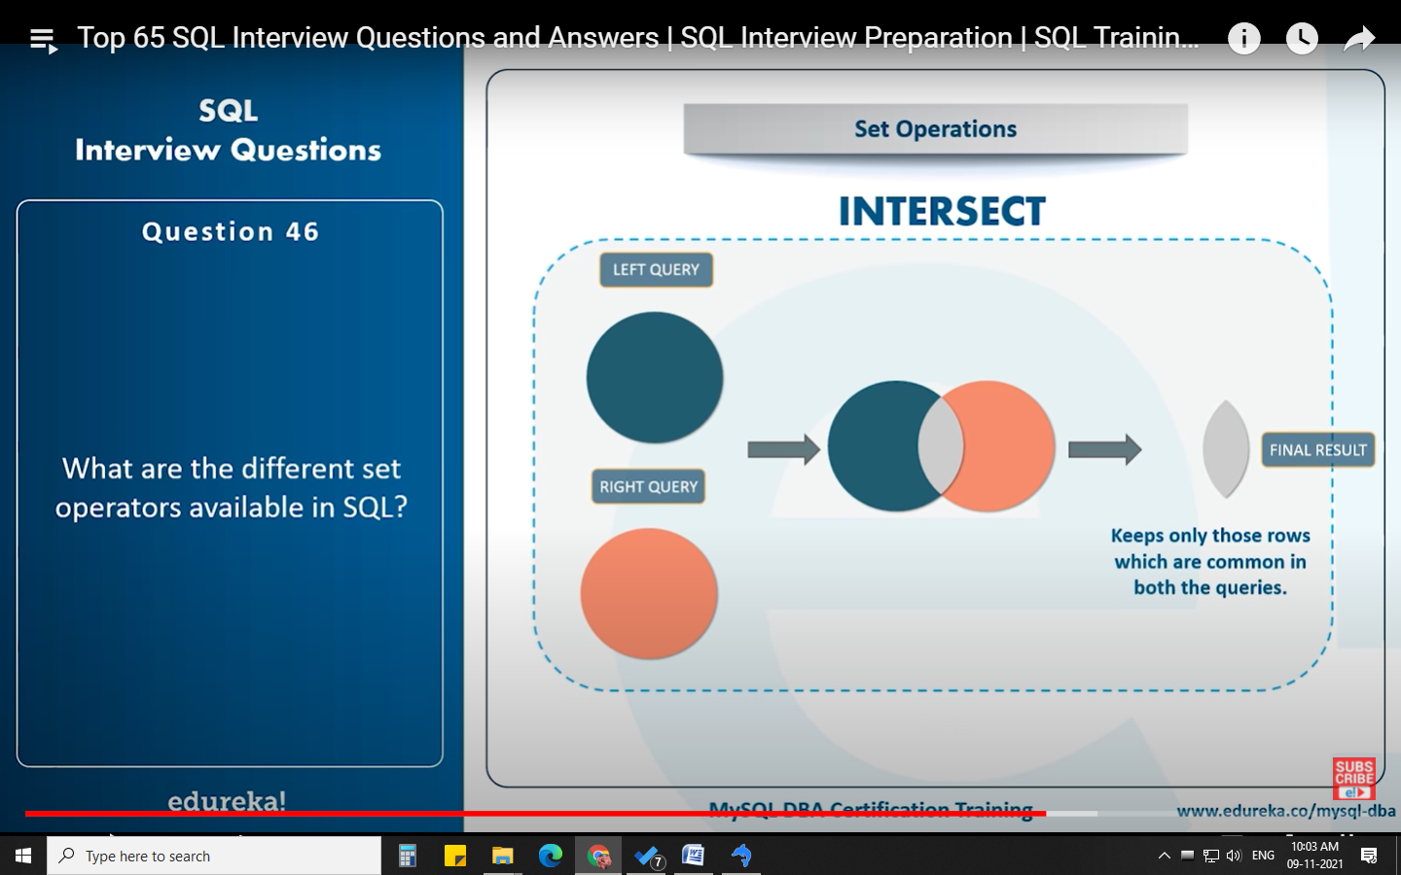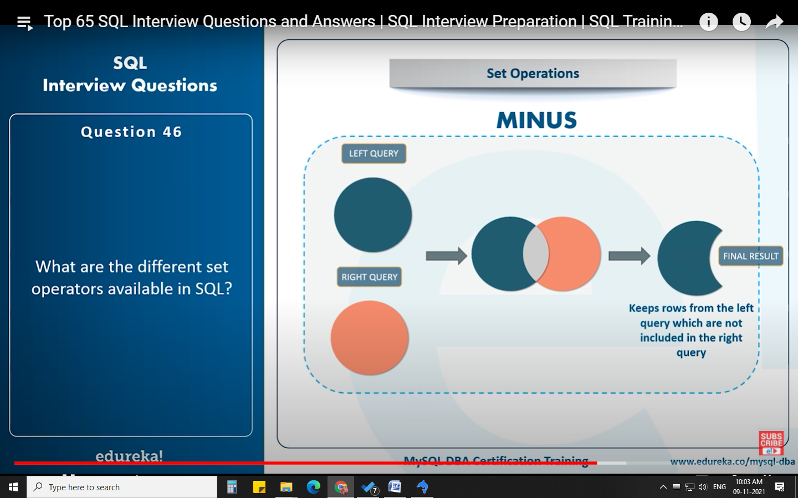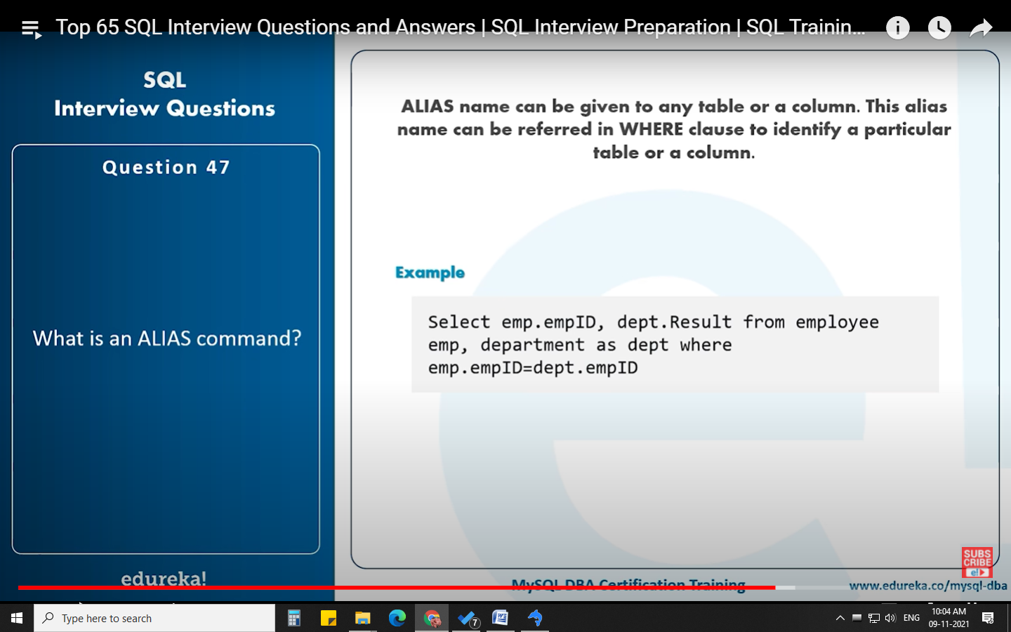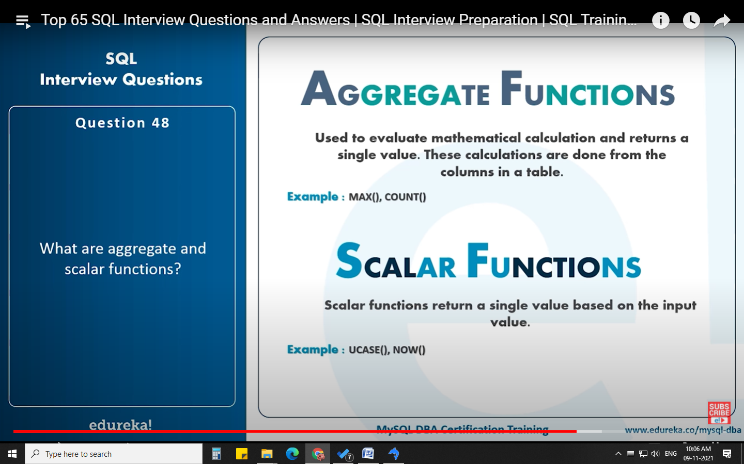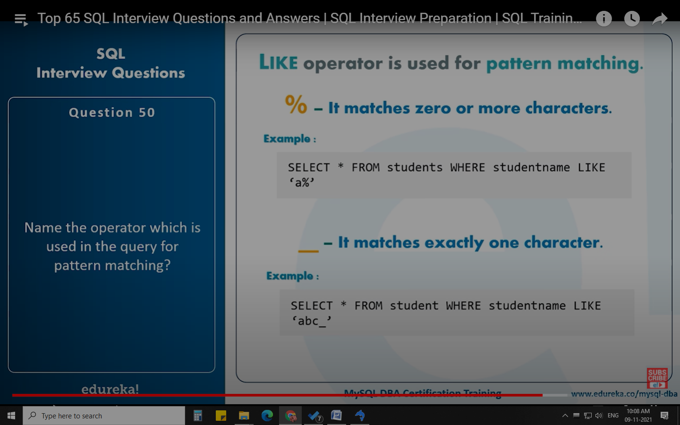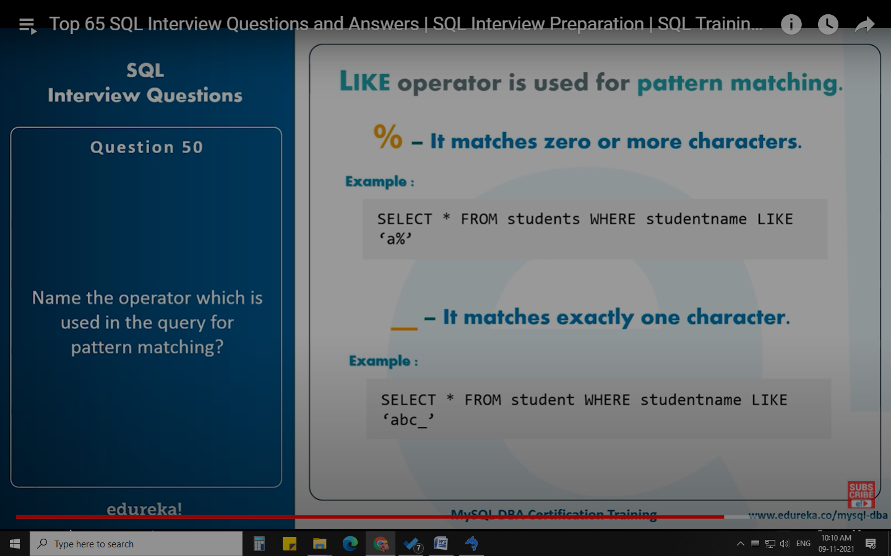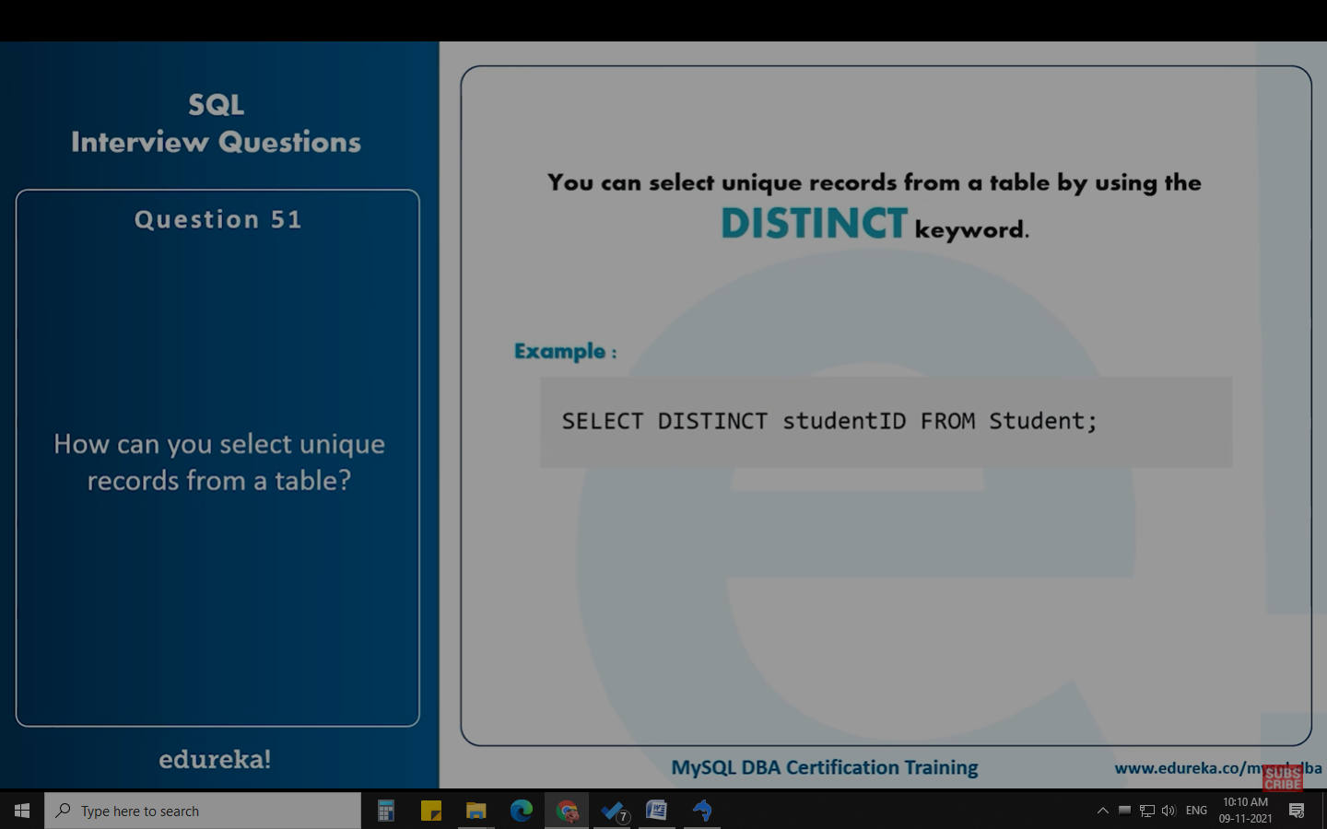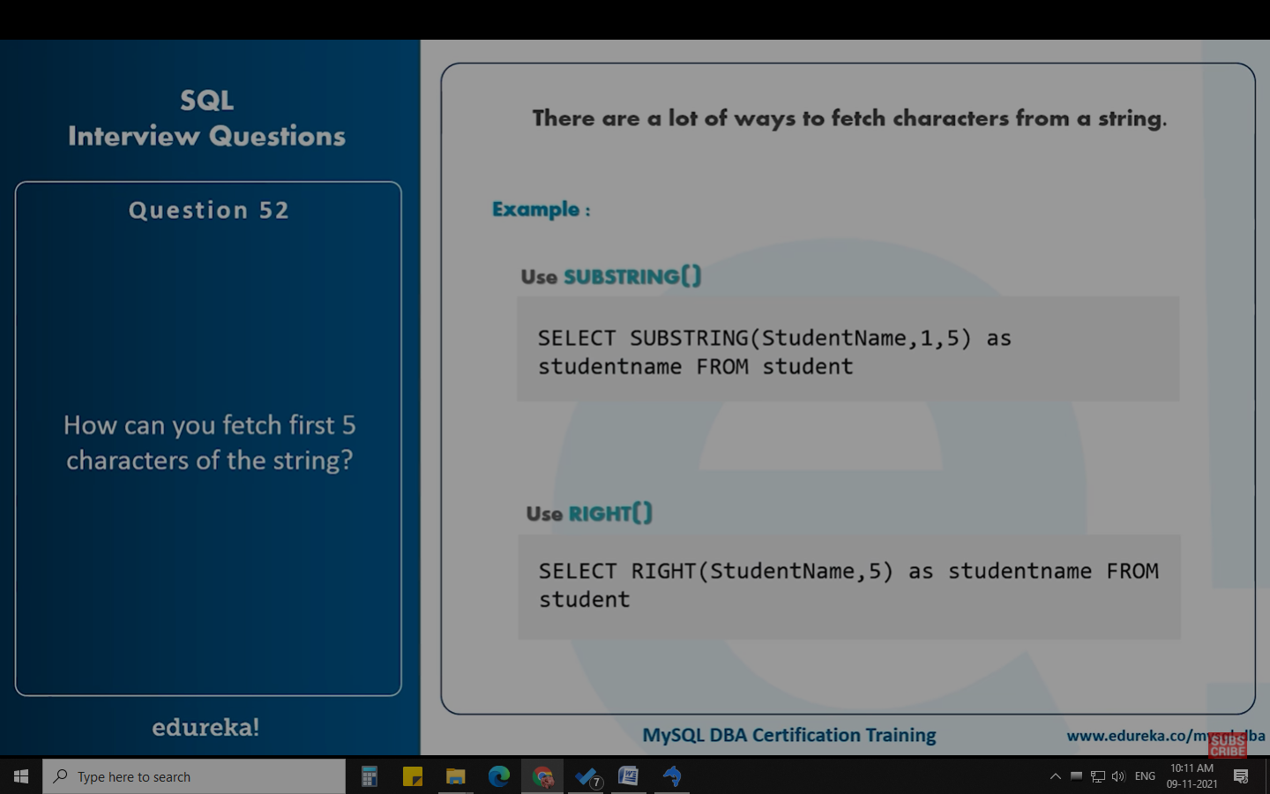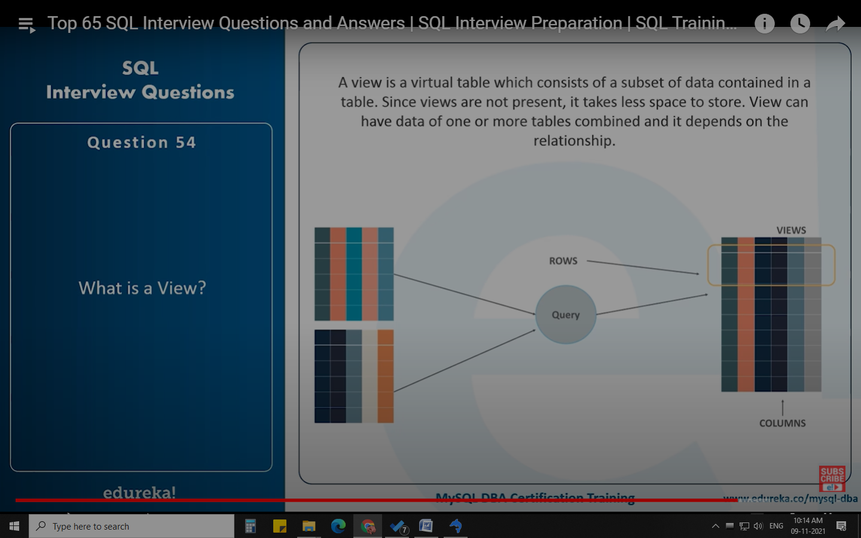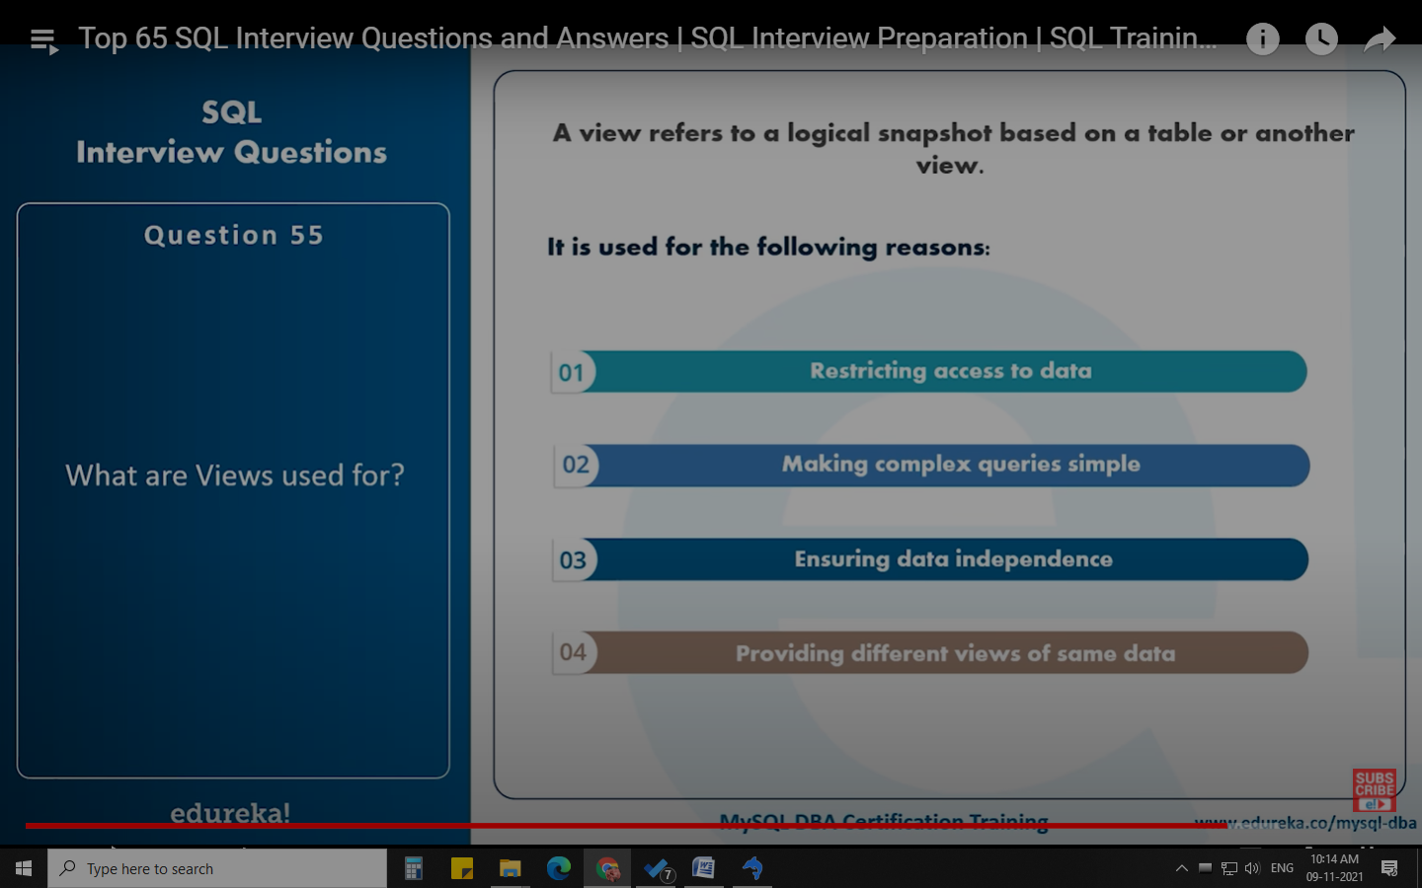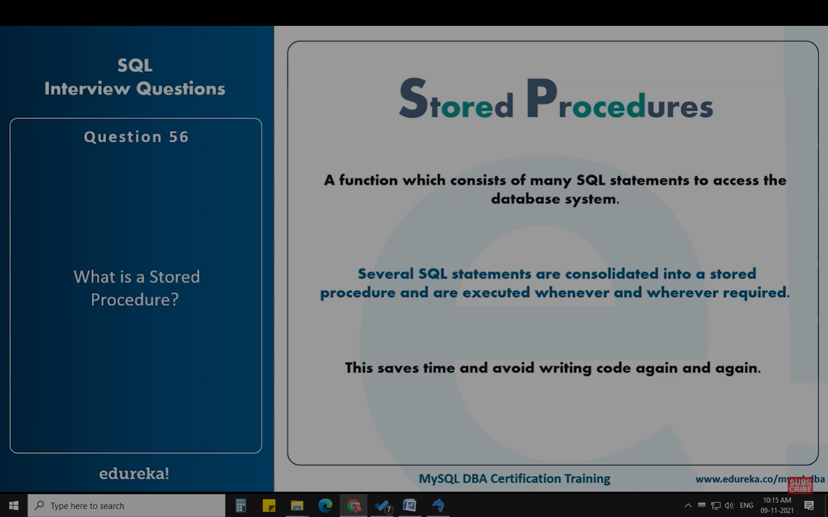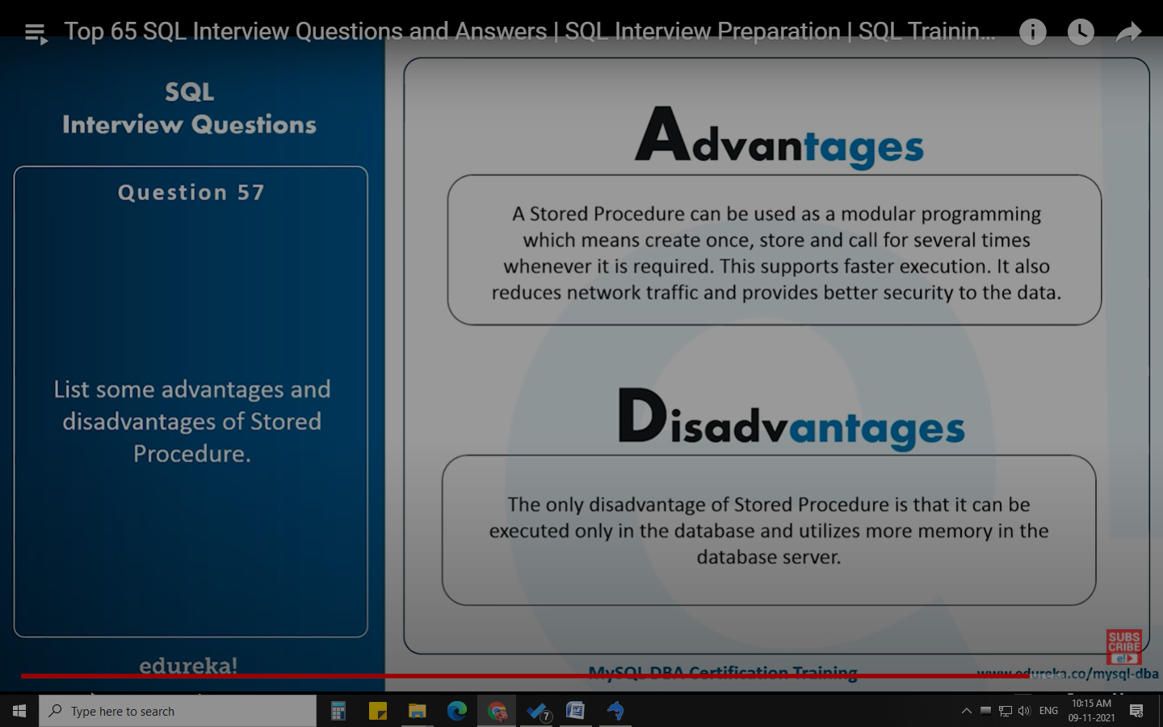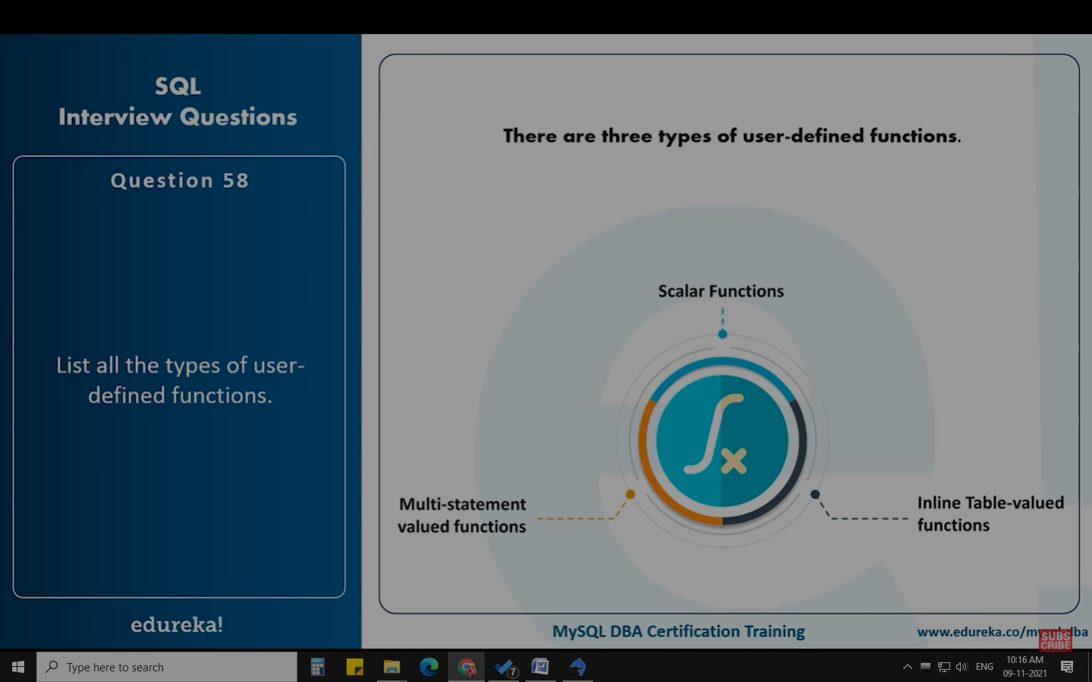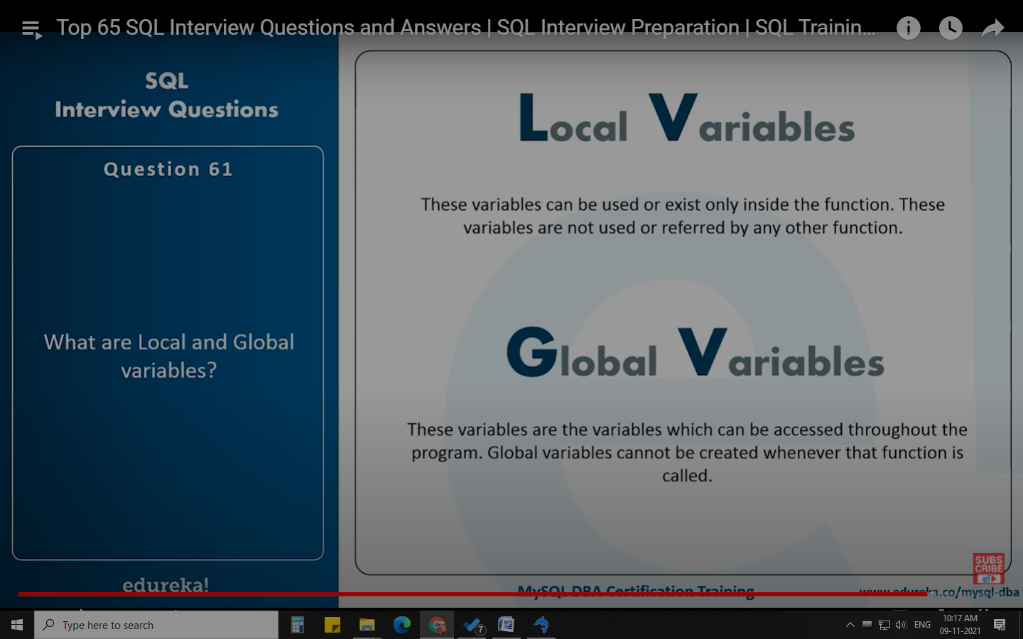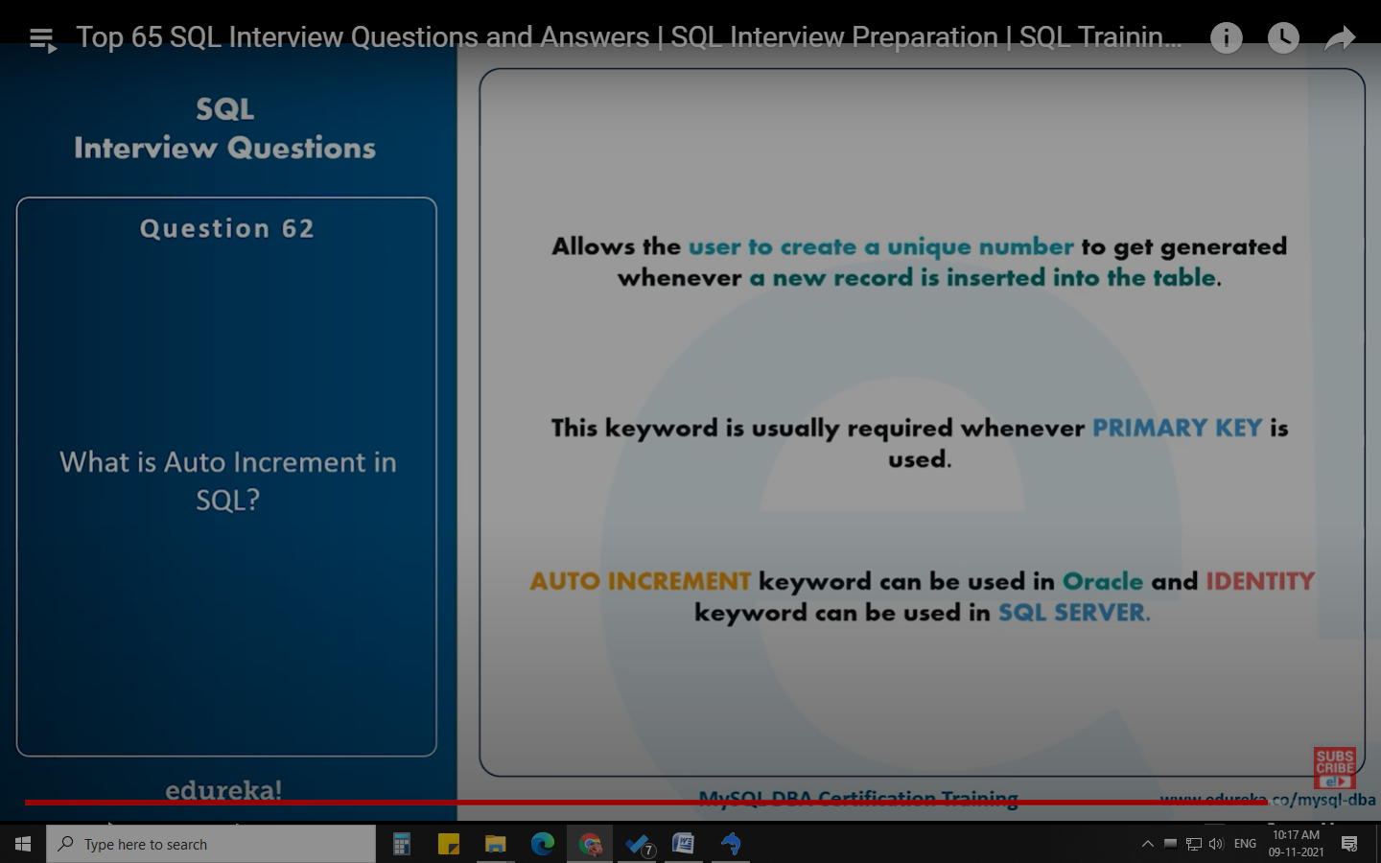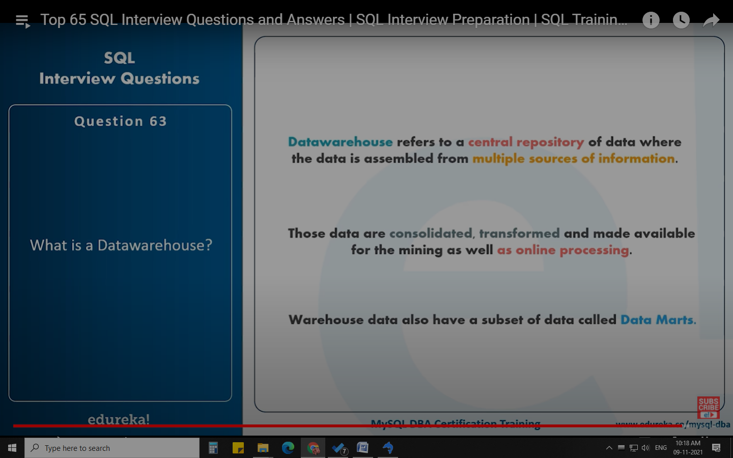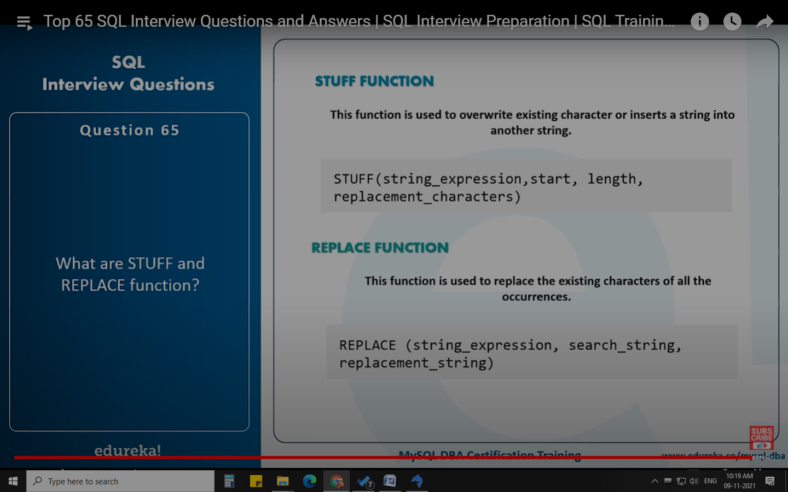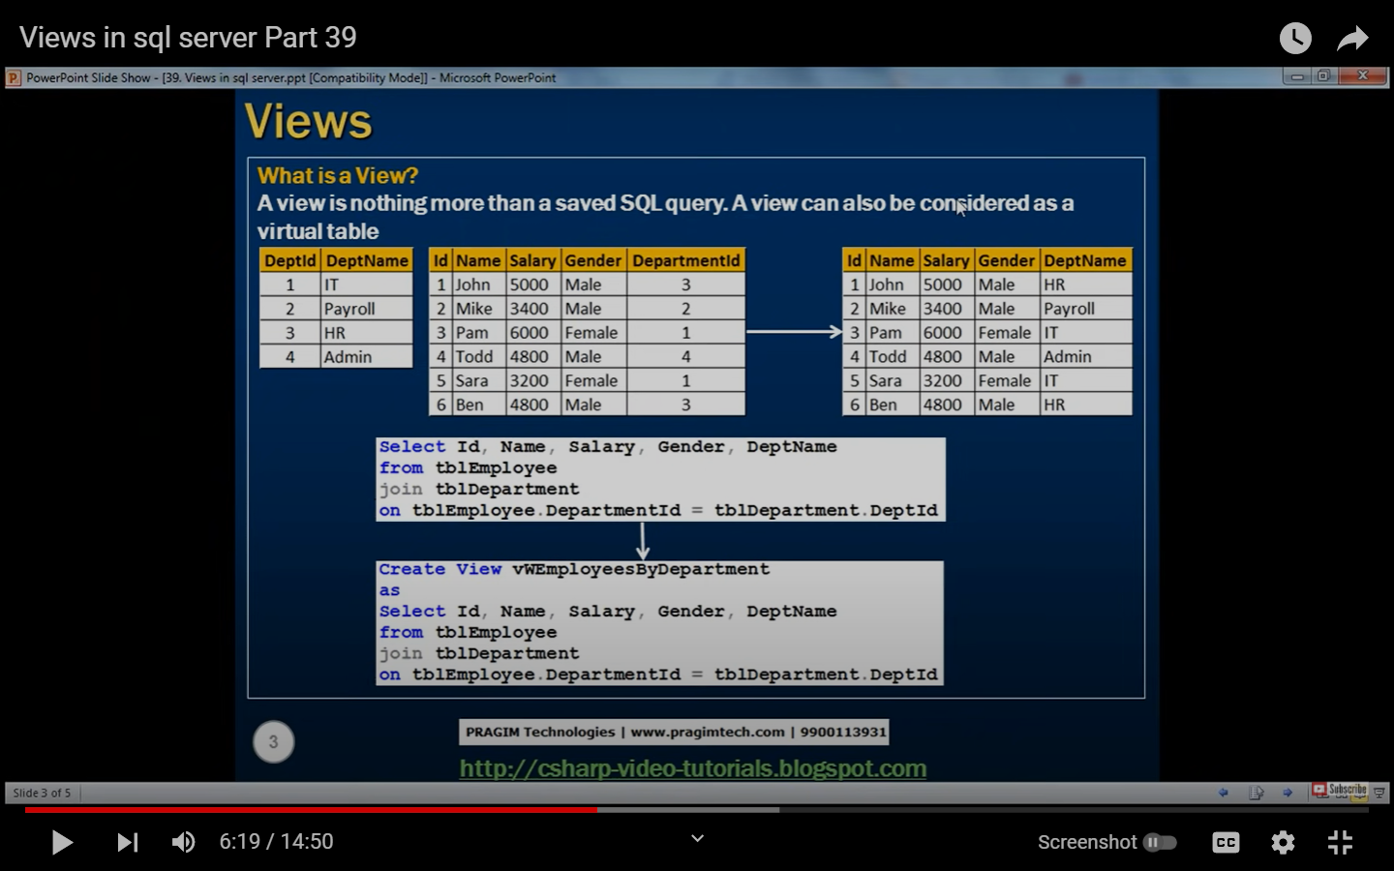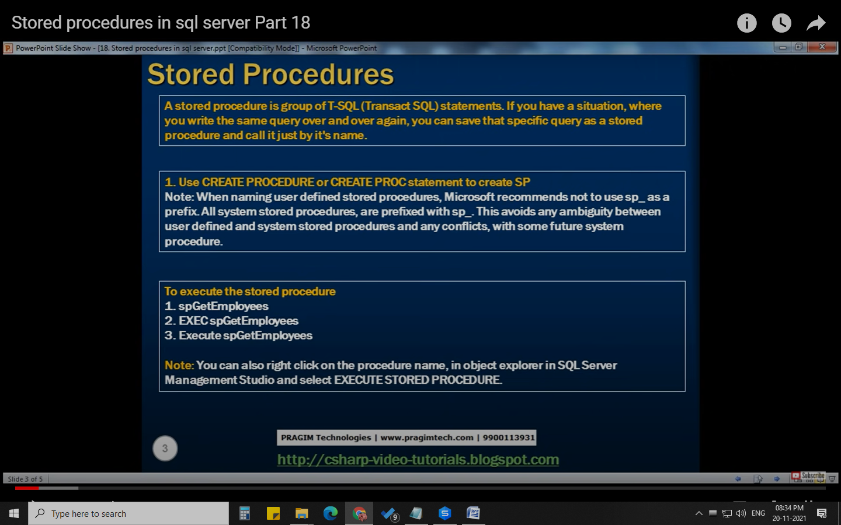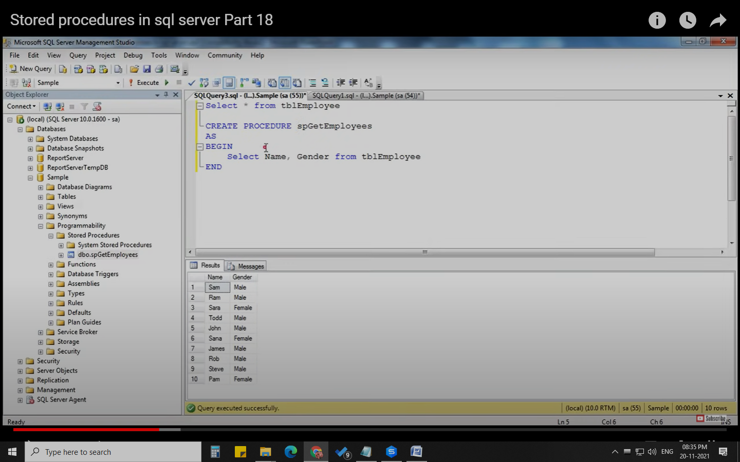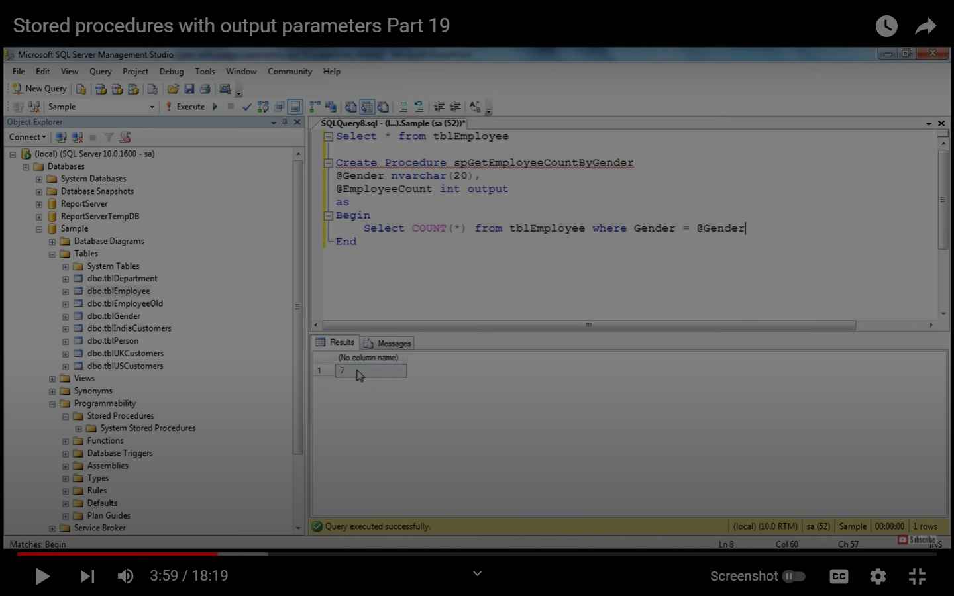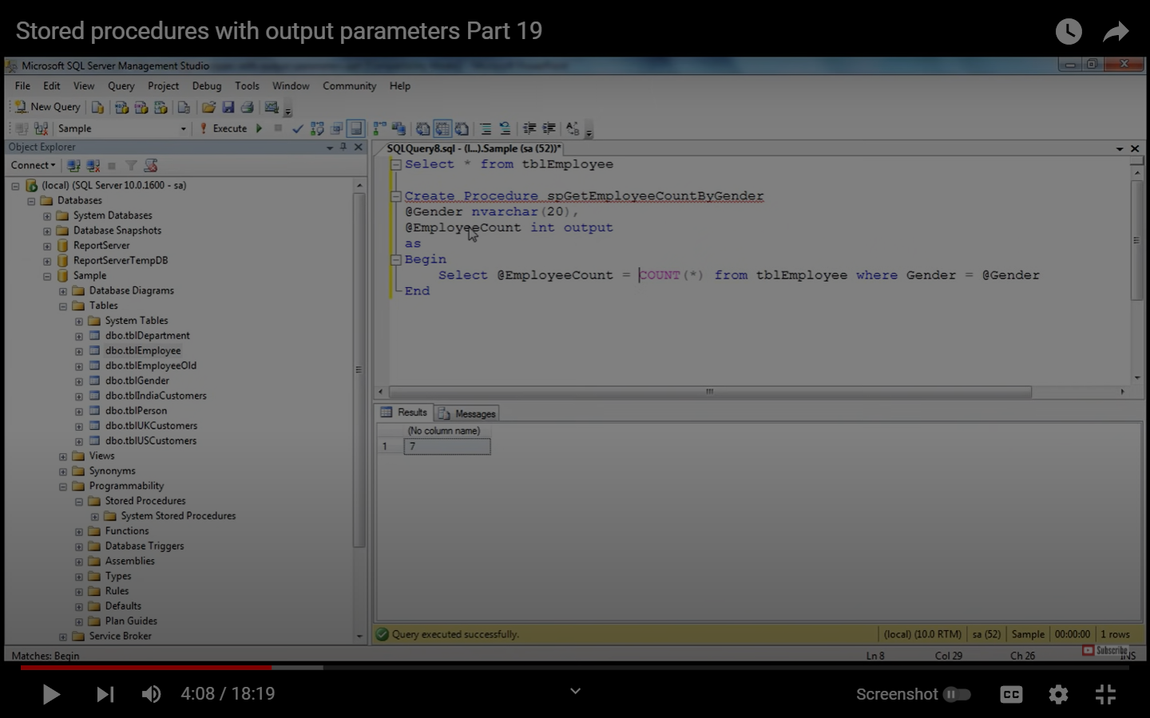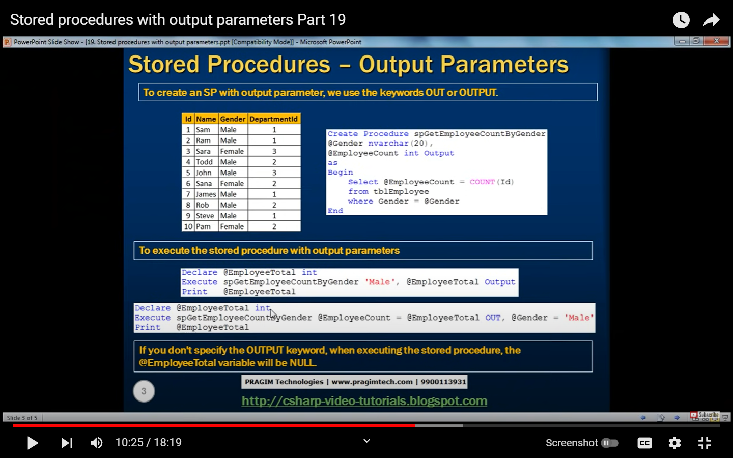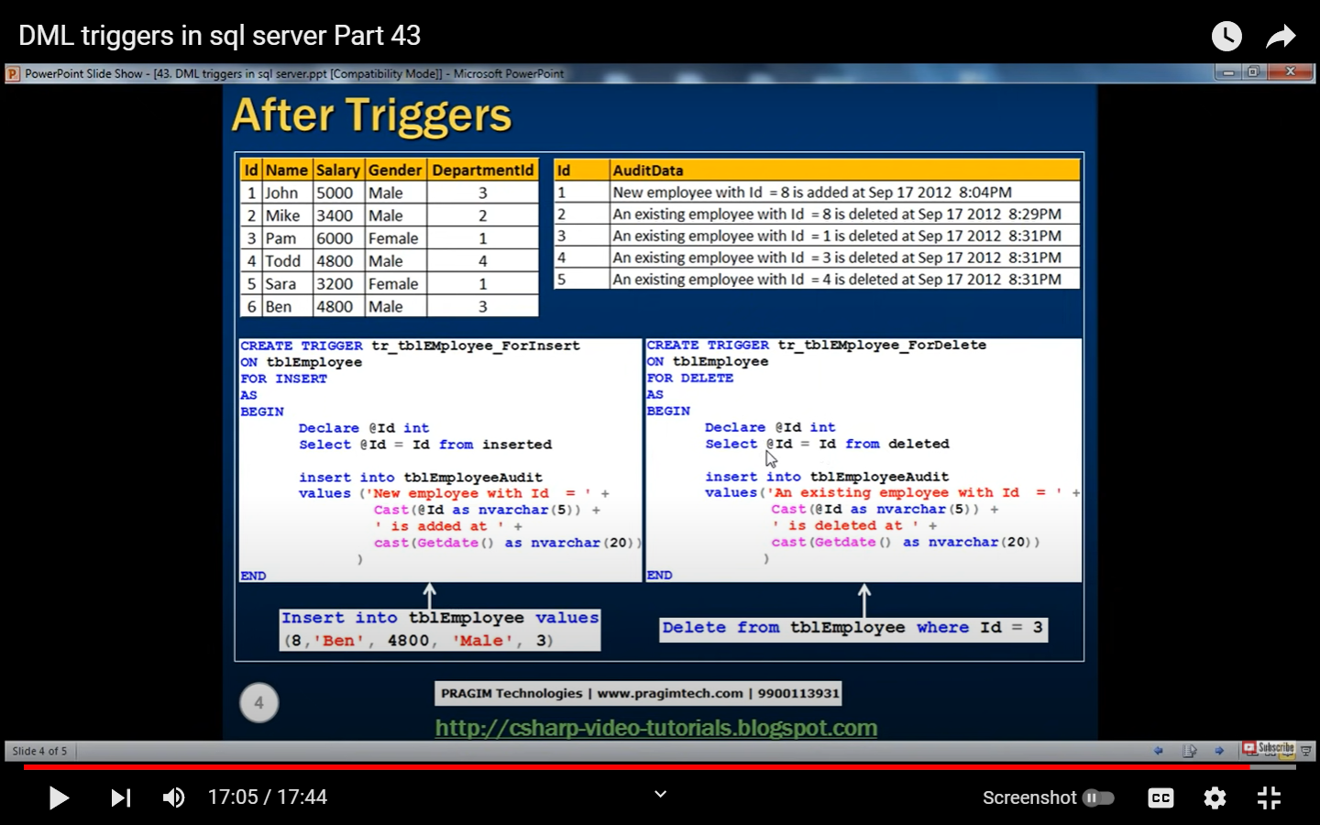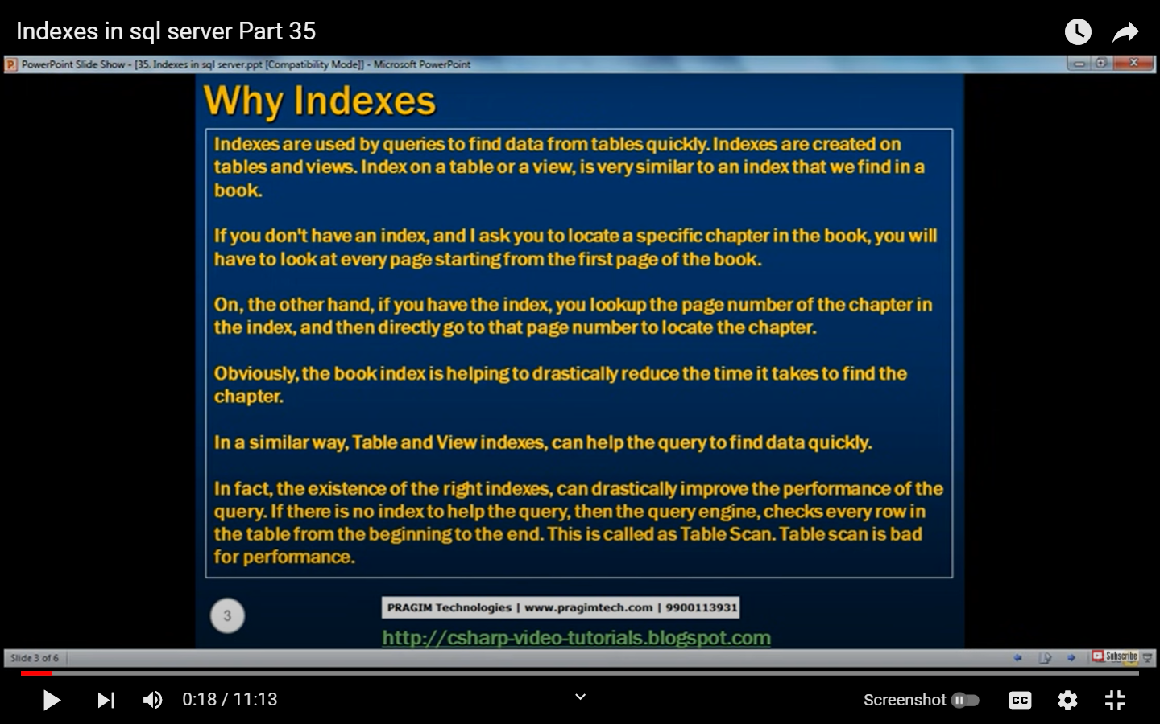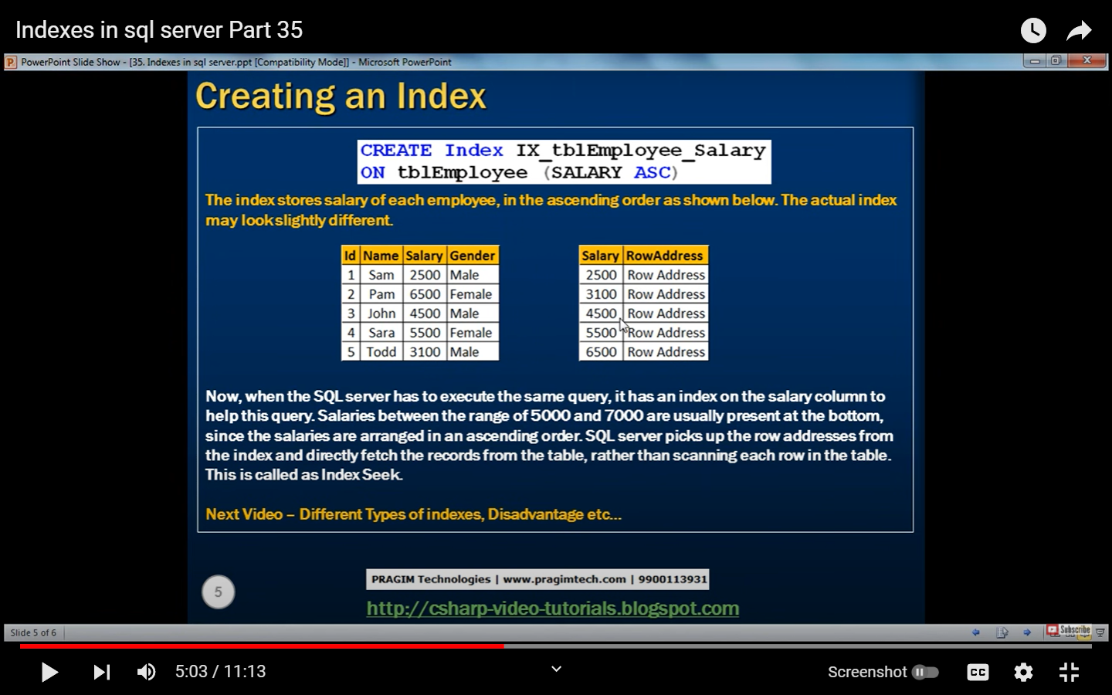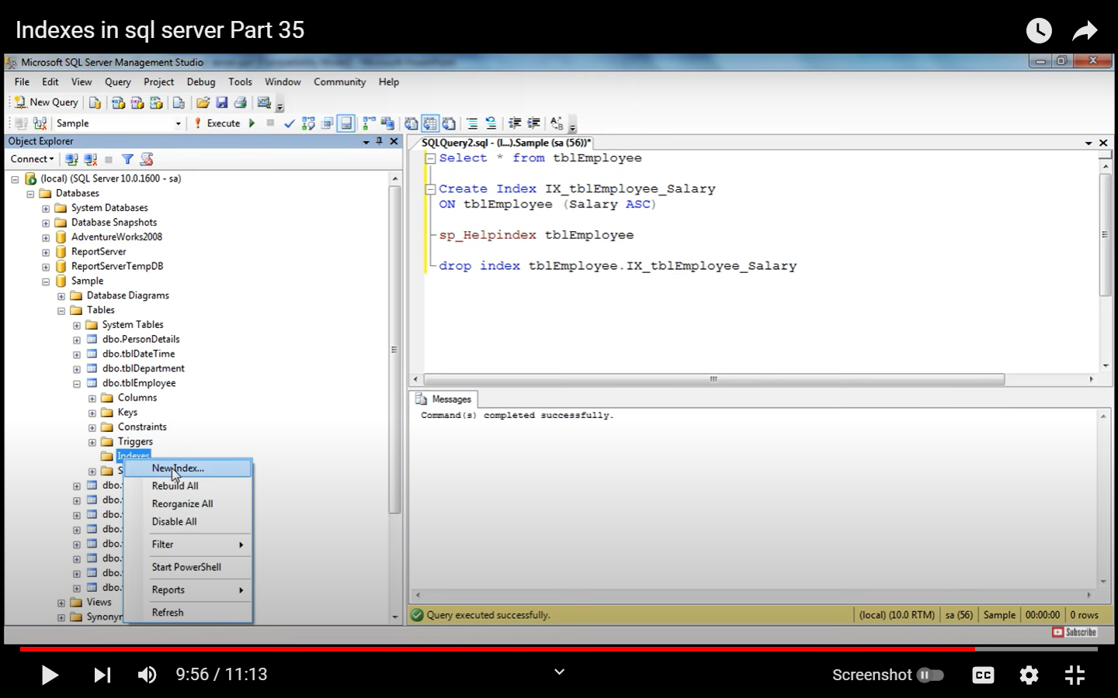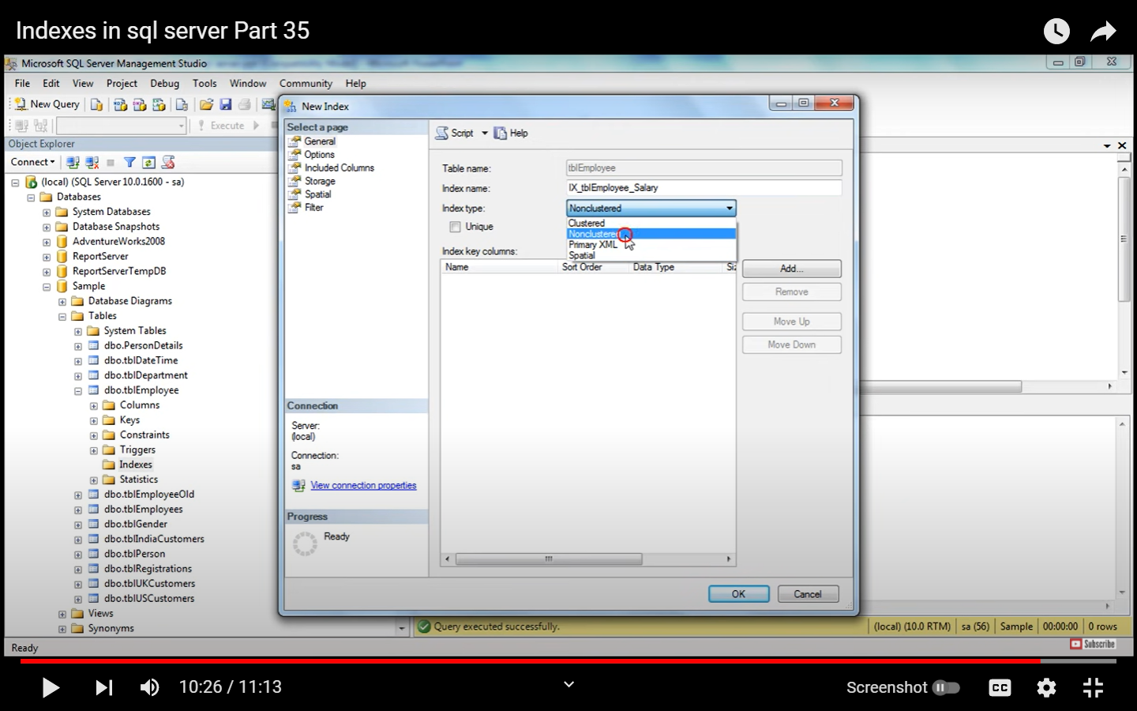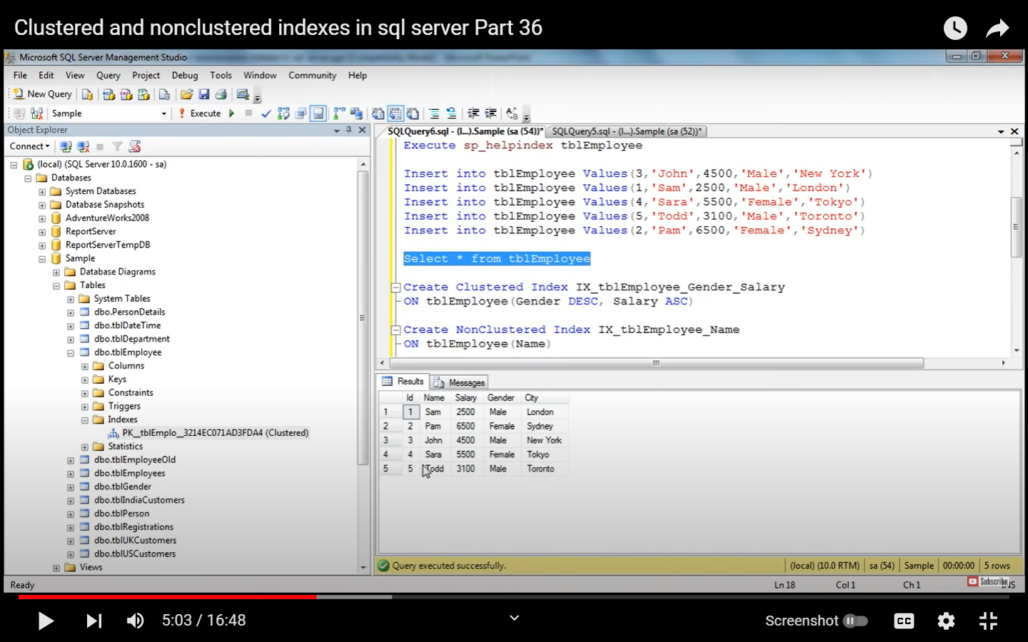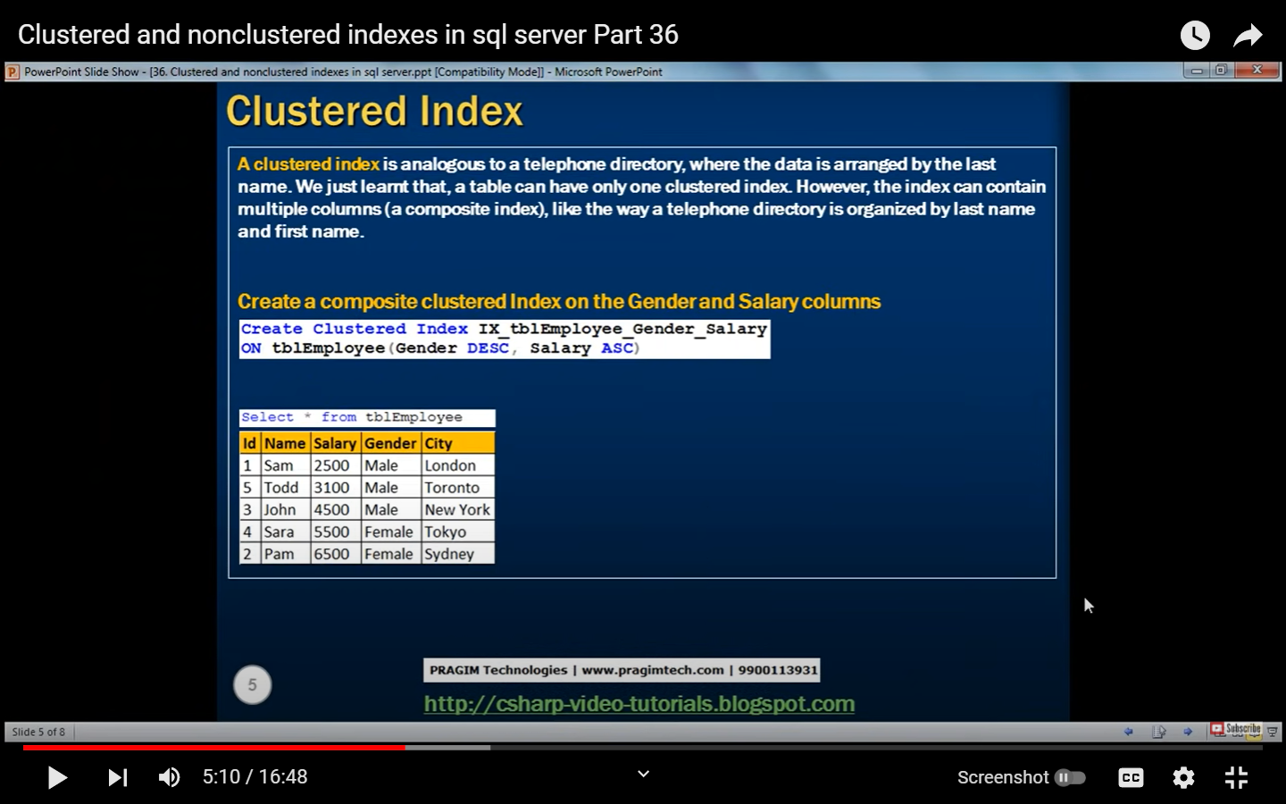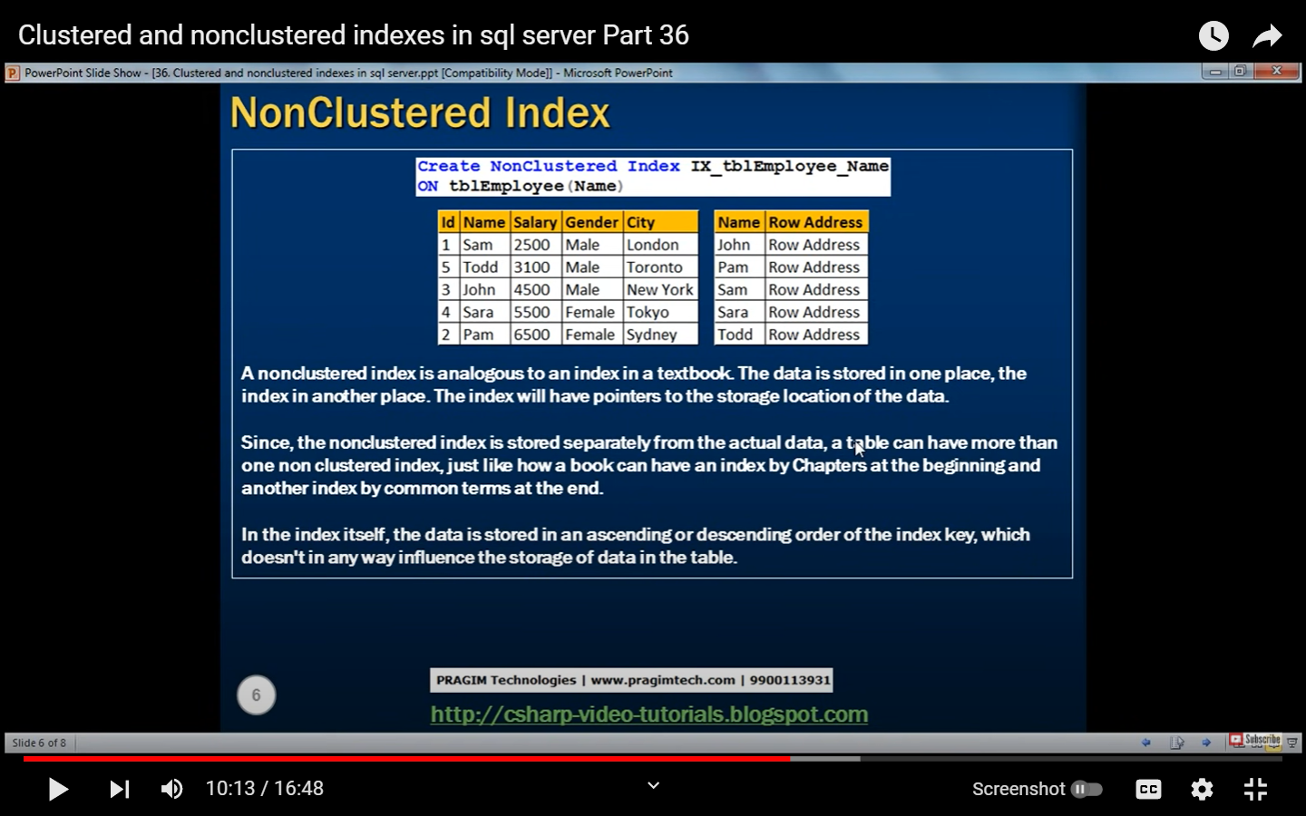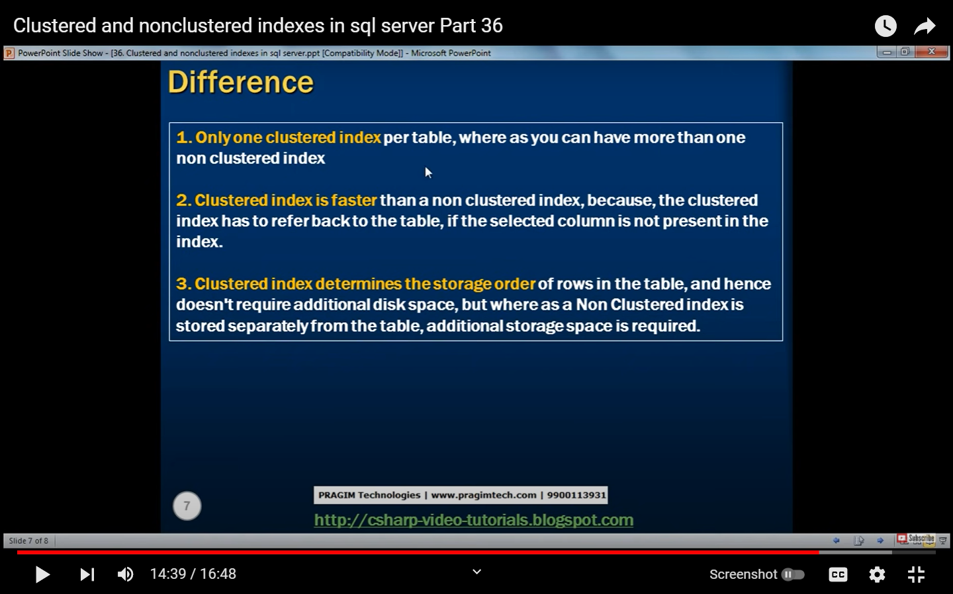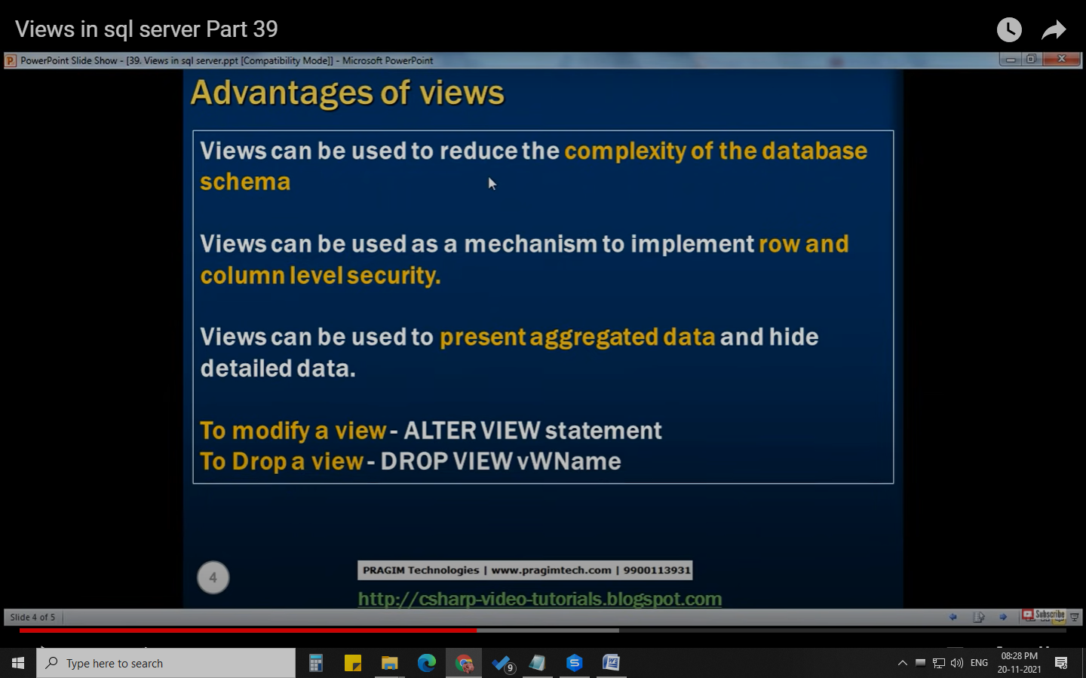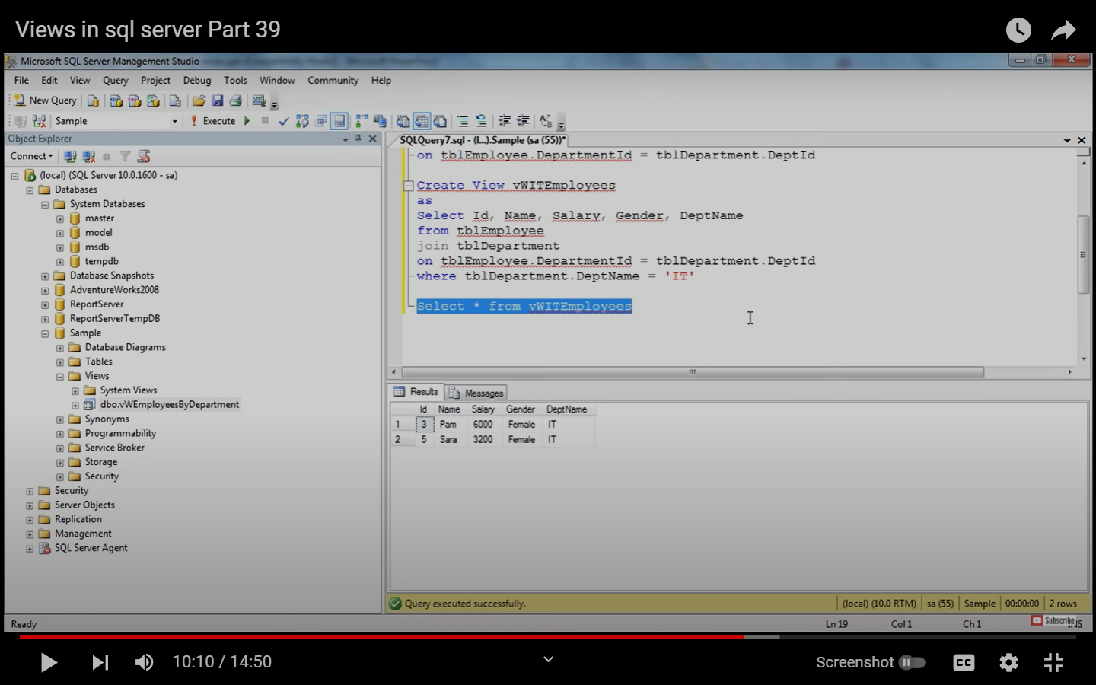

********************************************QUERY***********************************

USE mine;

show databases;

drop DATABASE mine;

CREATE database mine;

select * from branch;

select * from branch_supplier;

select * from client;

select * FROM works_with;

SELECT * from employee;

UPDATE employee

SET branch_id = 0

WHERE branch_id = 3;

UPDATE employee

SET branch_id = 3

WHERE emp_id in (106,107,108);

# Comment

-- Comment

/* Comment */

select first_name, last_name, salary from employee where salary>70000;

-- male female count

select sex,count(sex) from employee group by sex;

-- which employee is associated with which branch;

SELECT CONCAT(emp.first_name ,'_',emp.last_name) AS empName, br.branch_name from employee as emp join branch as br on emp.branch_id=br.branch_id ;

-- name of the branch manager

SELECT b.branch_name,b.mgr_id,CONCAT(e.first_name ,'_',e.last_name) AS managerName

FROM branch b JOIN employee e ON b.mgr_id = e.emp_id;

-- Find names of all employees who have sold over 50,000

SELECT employee.first_name, employee.last_name

FROM employee

WHERE employee.emp_id IN (SELECT works_with.emp_id

FROM works_with

WHERE works_with.total_sales > 50000

);

use mine;

CREATE TABLE employee (

emp_id INT PRIMARY KEY,

first_name VARCHAR(40),

last_name VARCHAR(40),

birth_day DATE,

sex VARCHAR(1),

salary INT,

super_id INT,

branch_id INT

);

CREATE TABLE branch (

branch_id INT PRIMARY KEY,

branch_name VARCHAR(40),

mgr_id INT,

mgr_start_date DATE,

FOREIGN KEY(mgr_id) REFERENCES employee(emp_id) ON DELETE SET NULL

);

ALTER TABLE employee

ADD FOREIGN KEY(branch_id)

REFERENCES branch(branch_id)

ON DELETE SET NULL;

ALTER TABLE employee

ADD FOREIGN KEY(super_id)

REFERENCES employee(emp_id)

ON DELETE SET NULL;

CREATE TABLE client (

client_id INT PRIMARY KEY,

client_name VARCHAR(40),

branch_id INT,

FOREIGN KEY(branch_id) REFERENCES branch(branch_id) ON DELETE SET NULL

);

CREATE TABLE works_with (

emp_id INT,

client_id INT,

total_sales INT,

PRIMARY KEY(emp_id, client_id),

FOREIGN KEY(emp_id) REFERENCES employee(emp_id) ON DELETE CASCADE,

FOREIGN KEY(client_id) REFERENCES client(client_id) ON DELETE CASCADE

);

CREATE TABLE branch_supplier (

branch_id INT,

supplier_name VARCHAR(40),

supply_type VARCHAR(40),

PRIMARY KEY(branch_id, supplier_name),

FOREIGN KEY(branch_id) REFERENCES branch(branch_id) ON DELETE CASCADE

);

-- -----------------------------------------------------------------------------

-- Corporate

INSERT INTO employee VALUES(100, 'David', 'Wallace', '1967-11-17', 'M', 250000, NULL, NULL);

INSERT INTO branch VALUES(1, 'Corporate', 100, '2006-02-09');

UPDATE employee

SET branch_id = 1

WHERE emp_id = 100;

INSERT INTO employee VALUES(101, 'Jan', 'Levinson', '1961-05-11', 'F', 110000, 100, 1);

-- Scranton

INSERT INTO employee VALUES(102, 'Michael', 'Scott', '1964-03-15', 'M', 75000, 100, NULL);

INSERT INTO branch VALUES(2, 'Scranton', 102, '1992-04-06');

UPDATE employee

SET branch_id = 2

WHERE emp_id = 102;

INSERT INTO employee VALUES(103, 'Angela', 'Martin', '1971-06-25', 'F', 63000, 102, 2);

INSERT INTO employee VALUES(104, 'Kelly', 'Kapoor', '1980-02-05', 'F', 55000, 102, 2);

INSERT INTO employee VALUES(105, 'Stanley', 'Hudson', '1958-02-19', 'M', 69000, 102, 2);

-- Stamford

INSERT INTO employee VALUES(106, 'Josh', 'Porter', '1969-09-05', 'M', 78000, 100, NULL);

INSERT INTO branch VALUES(3, 'Stamford', 106, '1998-02-13');

UPDATE employee

SET branch_id = 3

WHERE emp_id = 106;

INSERT INTO employee VALUES(107, 'Andy', 'Bernard', '1973-07-22', 'M', 65000, 106, 3);

INSERT INTO employee VALUES(108, 'Jim', 'Halpert', '1978-10-01', 'M', 71000, 106, 3);

-- BRANCH SUPPLIER

INSERT INTO branch_supplier VALUES(2, 'Hammer Mill', 'Paper');

INSERT INTO branch_supplier VALUES(2, 'Uni-ball', 'Writing Utensils');

INSERT INTO branch_supplier VALUES(3, 'Patriot Paper', 'Paper');

INSERT INTO branch_supplier VALUES(2, 'J.T. Forms & Labels', 'Custom Forms');

INSERT INTO branch_supplier VALUES(3, 'Uni-ball', 'Writing Utensils');

INSERT INTO branch_supplier VALUES(3, 'Hammer Mill', 'Paper');

INSERT INTO branch_supplier VALUES(3, 'Stamford Lables', 'Custom Forms');

-- CLIENT

INSERT INTO client VALUES(400, 'Dunmore Highschool', 2);

INSERT INTO client VALUES(401, 'Lackawana Country', 2);

INSERT INTO client VALUES(402, 'FedEx', 3);

INSERT INTO client VALUES(403, 'John Daly Law, LLC', 3);

INSERT INTO client VALUES(404, 'Scranton Whitepages', 2);

INSERT INTO client VALUES(405, 'Times Newspaper', 3);

INSERT INTO client VALUES(406, 'FedEx', 2);

-- WORKS_WITH

INSERT INTO works_with VALUES(105, 400, 55000);

INSERT INTO works_with VALUES(102, 401, 267000);

INSERT INTO works_with VALUES(108, 402, 22500);

INSERT INTO works_with VALUES(107, 403, 5000);

INSERT INTO works_with VALUES(108, 403, 12000);

INSERT INTO works_with VALUES(105, 404, 33000);

INSERT INTO works_with VALUES(107, 405, 26000);

INSERT INTO works_with VALUES(102, 406, 15000);

INSERT INTO works_with VALUES(105, 406, 130000);

select * from branch;

select * from branch_supplier;

select * from client;

select * FROM works_with;

SELECT * from employee;

USE mine;

-- Find all employees ordered by salary

SELECT *

from employee

ORDER BY salary ASC;

-- Find all employees ordered by sex then name

SELECT *

from employee

ORDER BY sex, first_name;

-- Find the first 5 employees in the table

SELECT *

from employee

LIMIT 5;

-- Find the first and last names of all employees

SELECT first_name, employee.last_name

FROM employee;

-- Find the forename and surnames names of all employees

SELECT first_name AS forename, employee.last_name AS surname

FROM employee;

-- Find out all the different genders

SELECT DISTINCT sex

FROM employee;

-- Find all male employees

SELECT *

FROM employee

WHERE sex = 'M';

-- Find all employees at branch 2

SELECT *

FROM employee

WHERE branch_id = 2;

-- Find all employee's id's and names who were born after 1969

SELECT emp_id, first_name, last_name

FROM employee

WHERE birth_day >= 1970-01-01;

-- Find all female employees at branch 2

SELECT *

FROM employee

WHERE branch_id = 2 AND sex = 'F';

-- Find all employees who are female & born after 1969 or who make over 80000

SELECT *

FROM employee

WHERE (birth_day >= '1970-01-01' AND sex = 'F') OR salary > 80000;

-- Find all employees born between 1970 and 1975

SELECT *

FROM employee

WHERE birth_day BETWEEN '1970-01-01' AND '1975-01-01';

-- Find all employees named Jim, Michael, Johnny or David

SELECT *

FROM employee

WHERE first_name IN ('Jim', 'Michael', 'Johnny', 'David');

-- Find the number of employees

SELECT COUNT(emp_id)

FROM employee

;

-- Find the average of all employee's salaries

SELECT AVG(salary)

FROM employee

;

-- Find the sum of all employee's salaries

SELECT SUM(salary)

FROM employee;

-- Find out how many males and females there are

SELECT COUNT(sex), sex

FROM employee

GROUP BY sex;

-- Find the total sales of each salesman

SELECT emp_id,(total_sales) FROM works_with

GROUP BY emp_id;

SELECT emp_id,(total_sales) FROM works_with

GROUP BY client_id;

select * FROM works_with;

-- Find the total amount of money spent by each client

SELECT ww.client_id,SUM(ww.total_sales) FROM works_with ww

GROUP BY ww.client_id;

-- % = any # characters, _ = one character

SELECT * FROM client c;

-- Find any client's who are an LLC

SELECT * FROM client c

WHERE c.client_name LIKE '%LLC';

-- Find any branch suppliers who are in the label business

select * FROM branch_supplier;

SELECT *

FROM branch_supplier

WHERE supplier_name LIKE '% Label%';

-- Find any employee born on the 10th day of the month

SELECT * FROM employee;

SELECT *

FROM employee

WHERE birth_day LIKE '_____10%';

-- Find any clients who are schools

SELECT *

FROM client

WHERE client_name LIKE '%Highschool%';

-- Find a list of employee and branch names

SELECT e.emp_id,e.first_name FROM employee e

UNION

SELECT b.branch_name,b.branch_id FROM branch b;

SELECT employee.first_name AS Employee_Branch_Names

FROM employee

UNION

SELECT branch.branch_name

FROM branch;

-- Find a list of all clients & branch suppliers' names

SELECT c.client_name FROM client c

UNION

SELECT bs.supplier_name FROM branch_supplier bs;

SELECT c.client_name,c.client_id FROM client c

UNION

SELECT bs.supplier_name,bs.branch_id FROM branch_supplier bs;

SELECT client.client_name AS Non_Employee_Entities, client.branch_id AS Branch_ID

FROM client

UNION

SELECT branch_supplier.supplier_name, branch_supplier.branch_id

FROM branch_supplier;

-- JOINS

SELECT employee.emp_id, employee.first_name, branch.branch_name

FROM employee

RIGHT JOIN branch -- LEFT JOIN, RIGHT JOIN

ON employee.emp_id = branch.mgr_id;

-- Find names of all employees who have sold over 50,000

SELECT e.first_name

FROM employee e

LEFT JOIN works_with ww ON e.emp_id = ww.emp_id

WHERE ww.total_sales>50000;

SELECT e.first_name FROM employee e WHERE e.emp_id IN

(

SELECT ww.emp_id FROM works_with ww WHERE ww.total_sales>50000

);

-- Find all clients who are handles by the branch that Michael Scott manages

-- Assume you know Michael's ID

SELECT client.client_id, client.client_name

FROM client

WHERE client.branch_id = (SELECT branch.branch_id

FROM branch

WHERE branch.mgr_id = 102);

-- Find all clients who are handles by the branch that Michael Scott manages

-- Assume you DONT'T know Michael's ID

SELECT c.client_name FROM client c WHERE c.branch_id IN

(SELECT b.branch_id FROM branch b WHERE b.mgr_id IN

(SELECT e.emp_id FROM employee e WHERE e.first_name='Michael'));

-- Find the names of employees who work with clients handled by the scranton branch

SELECT e.first_name FROM employee e

WHERE e.branch_id= (SELECT b.branch_id FROM branch b WHERE b.branch_name='scranton')

AND e.emp_id IN (SELECT ww.emp_id FROM works_with ww);

SELECT employee.first_name, employee.last_name

FROM employee

WHERE employee.emp_id IN (

SELECT works_with.emp_id

FROM works_with

)

AND employee.branch_id = 2;

-- Find the names of all clients who have spent more than 100,000 dollars

SELECT c.client_name FROM client c

WHERE c.client_id IN (

SELECT client_id FROM (

SELECT ww.client_id,SUM(ww.total_sales)AS total FROM works_with ww

GROUP BY ww.client_id

) AS totals

WHERE totals.total>100000

)

;

SELECT client.client_name

FROM client

WHERE client.client_id IN (

SELECT client_id

FROM (

SELECT SUM(works_with.total_sales) AS totals, client_id

FROM works_with

GROUP BY client_id) AS total_client_sales

WHERE totals > 100000

);

-- CREATE

-- TRIGGER `event_name` BEFORE/AFTER INSERT/UPDATE/DELETE

-- ON `database`.`table`

-- FOR EACH ROW BEGIN

-- -- trigger body

-- -- this code is applied to every

-- -- inserted/updated/deleted row

-- END;

CREATE TABLE trigger_test (

message VARCHAR(100)

);

DELIMITER $$

CREATE

TRIGGER my_trigger BEFORE INSERT

ON employee

FOR EACH ROW BEGIN

INSERT INTO trigger_test VALUES('added new employee');

END$$

DELIMITER ;

INSERT INTO employee

VALUES(109, 'Oscar', 'Martinez', '1968-02-19', 'M', 69000, 106, 3);

DELIMITER $$

CREATE

TRIGGER my_trigger BEFORE INSERT

ON employee

FOR EACH ROW BEGIN

INSERT INTO trigger_test VALUES(NEW.first_name);

END$$

DELIMITER ;

INSERT INTO employee

VALUES(110, 'Kevin', 'Malone', '1978-02-19', 'M', 69000, 106, 3);

DELIMITER $$

CREATE

TRIGGER my_trigger BEFORE INSERT

ON employee

FOR EACH ROW BEGIN

IF NEW.sex = 'M' THEN

INSERT INTO trigger_test VALUES('added male employee');

ELSEIF NEW.sex = 'F' THEN

INSERT INTO trigger_test VALUES('added female');

ELSE

INSERT INTO trigger_test VALUES('added other employee');

END IF;

END$$

DELIMITER ;

INSERT INTO employee

VALUES(111, 'Pam', 'Beesly', '1988-02-19', 'F', 69000, 106, 3);

DROP TRIGGER my_trigger;

**JOINS**

use mine;

CREATE TABLE student (

student_id INT PRIMARY KEY,

first_name VARCHAR(40),

last_name VARCHAR(40),

birth_day DATE,

sex VARCHAR(1),

course_id INT,

FOREIGN KEY(course_id) REFERENCES courses(course_id) ON DELETE SET NULL

);

ALTER TABLE student

DROP COLUMN age;

CREATE TABLE teacher (

teacher_id INT PRIMARY KEY,

first_name VARCHAR(40),

last_name VARCHAR(40),

birth_day DATE,

sex VARCHAR(1),

salary INT,

experience INT,

course_id INT,

FOREIGN KEY(course_id) REFERENCES courses(course_id) ON DELETE SET NULL

);

CREATE TABLE courses (

course_id INT PRIMARY KEY,

course_name VARCHAR(40)

);

select * from student;

select * from teacher;

select * from courses;

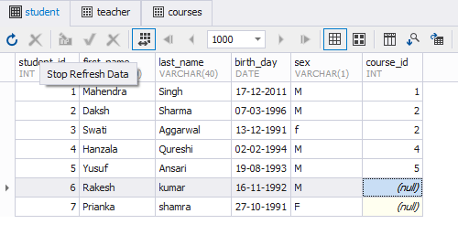

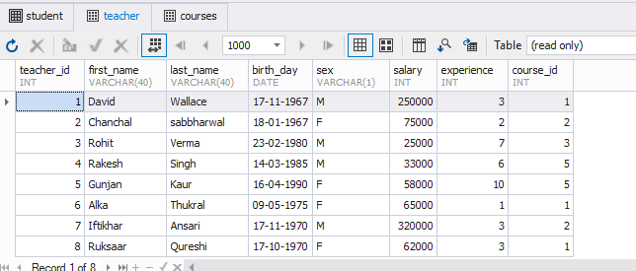

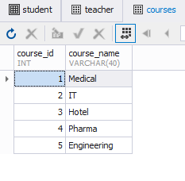

INSERT INTO student VALUES(1, 'Mahendra', 'Singh', '1995-10-07', 'M', 1);

INSERT INTO student VALUES(2, 'Daksh', 'Sharma', '1996-03-07', 'M', 2);

INSERT INTO student VALUES(3, 'Swati', 'Aggarwal', '1991-12-13', 'f', 2);

INSERT INTO student VALUES(4, 'Hanzala', 'Qureshi', '1994-02-02', 'M', 4);

INSERT INTO student VALUES(5, 'Yusuf', 'Ansari', '1993-08-19', 'M', 3);

INSERT INTO student VALUES(6, 'Rakesh', 'kumar', '1992-11-16', 'M', 5);

INSERT INTO student VALUES(7, 'Prianka', 'shamra', '1991-10-27', 'F', 1);

INSERT INTO teacher VALUES(8, 'Ruksaar', 'Qureshi', '1970-10-17', 'F', 62000, 5, 1);

INSERT INTO teacher VALUES(2, 'Chanchal', 'sabbharwal', '1967-01-18', 'F', 75000, 5, 2);

INSERT INTO teacher VALUES(3, 'Rohit', 'Verma', '1980-02-23', 'M', 25000, 5, 3);

INSERT INTO teacher VALUES(4, 'Rakesh', 'Singh', '1985-03-14', 'M', 33000, 5, 4);

INSERT INTO teacher VALUES(5, 'Gunjan', 'Kaur', '1990-04-16', 'F', 58000, 5, 5);

INSERT INTO teacher VALUES(6, 'Alka', 'Thukral', '1975-05-09', 'F', 65000, 5, 1);

INSERT INTO teacher VALUES(7, 'Iftikhar', 'Ansari', '1970-11-17', 'M', 320000, 5, 2);

INSERT INTO courses VALUES(1, 'Medical');

INSERT INTO courses VALUES(2, 'IT');

INSERT INTO courses VALUES(3, 'Hotel');

INSERT INTO courses VALUES(4, 'Pharma');

INSERT INTO courses VALUES(5, 'Engineering');

UPDATE teacher

SET course_id = 5

WHERE course_id=4;

UPDATE student

SET course_id = 5

WHERE course_id=3;

**-- third highest salary**

SELECT salary FROM teacher

order by salary DESC limit 2

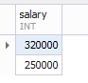

**-- by sub query**

select salary from

(SELECT salary FROM teacher

order by salary DESC limit 3) as sal

order by salary asc limit 1;

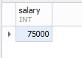

**-- by limit n-1**

SELECT salary

FROM teacher

ORDER BY salary desc limit 2,1;

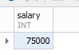

**-- by nesting**

SELECT MAX(salary) AS salary

FROM teacher

WHERE salary < (SELECT MAX(salary)

FROM teacher

WHERE salary < (SELECT MAX(salary)

FROM teacher)

);



**-- all joins, union,intersect,minus**

select * from student as st

CROSS JOIN courses as cr;

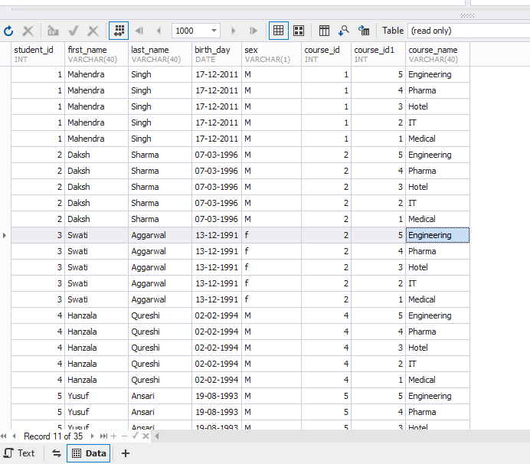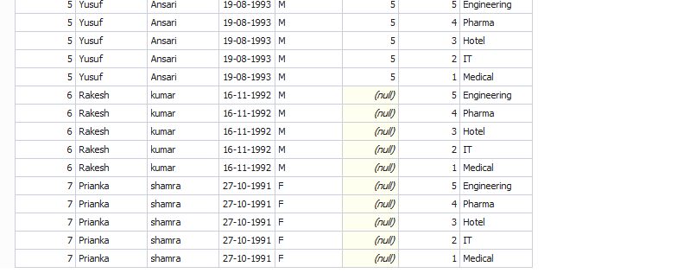

**-- common data between two tables with duplicates**

select * from student as st

INNER JOIN courses as cr

ON st.course_id=cr.course_id;

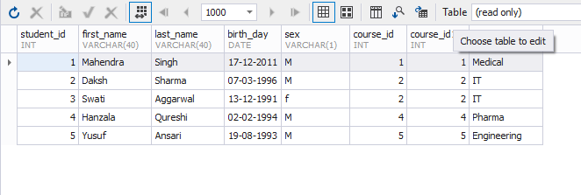

**-- all data of left table and common data from right table**

select * from student as st

LEFT JOIN courses as cr

ON st.course_id=cr.course_id;

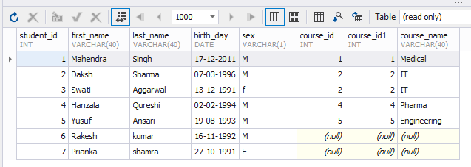

**-- left join and left outer join are same.**

select * from student as st

LEFT OUTER JOIN courses as cr

ON st.course_id=cr.course_id;

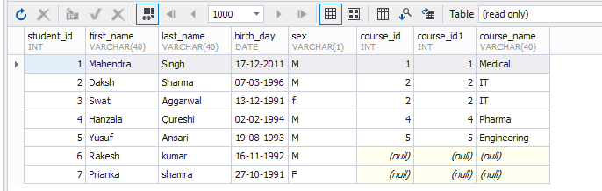

**-- all data of right table and common data from left table**

select * from student as st

RIGHT JOIN courses as cr

ON st.course_id=cr.course_id;

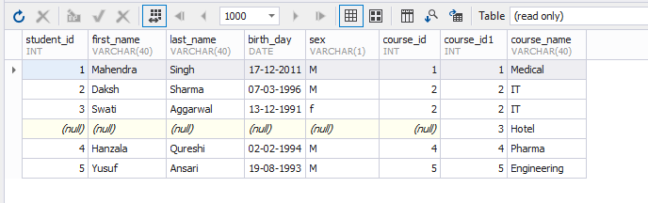

-- right join and right outer join are same.

select * from student as st

RIGHT OUTER JOIN courses as cr

ON st.course_id=cr.course_id;



**-- left join + right join data with duplicates**

**-- mysql dont have full joins thats why error in below query so instead we can use UNION**

select st.student_id,st.first_name,st.last_name,st.birth_day from student as st

FULL OUTER JOIN courses as cr

ON st.course_id=cr.course_id

order by st.student_id;

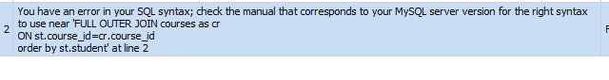

**-- left join + right join data without duplicates**

select * from student as st

LEFT JOIN courses as cr

ON st.course_id=cr.course_id

UNION

select * from student as st

RIGHT JOIN courses as cr

ON st.course_id=cr.course_id;

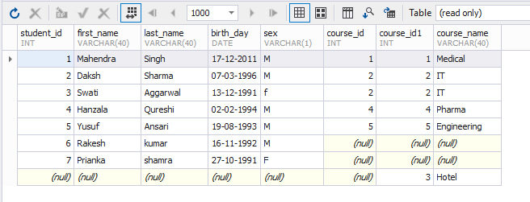

**-- if we want duplicates also**

select * from student as st

LEFT JOIN courses as cr

ON st.course_id=cr.course_id

UNION ALL

select * from student as st

RIGHT JOIN courses as cr

ON st.course_id=cr.course_id;

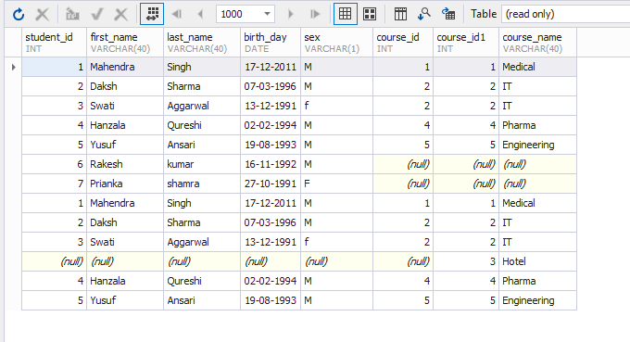

-- MYSQL doesnt support intersect but we can emulate by using INNER JOIN and IN clause

select * from student as st

LEFT JOIN courses as cr

ON st.course_id=cr.course_id

INTERSECT

select * from student as st

RIGHT JOIN courses as cr

ON st.course_id=cr.course_id;

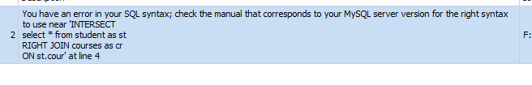

**-- using INNER JOIN**

select * from student as st

INNER JOIN courses as cr

ON st.course_id=cr.course_id;

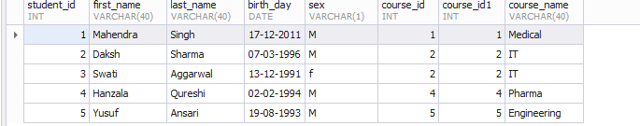

**-- using IN insided subquery**

select DISTINCT * from student

WHERE course_id IN(select course_id FROM courses );

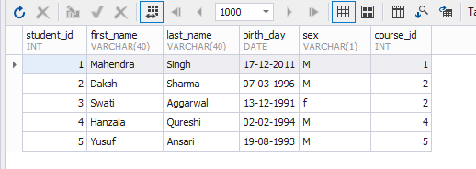

**-- data from first table than data from second table**

select st.student_id,st.first_name,st.last_name FROM student as st

UNION

select tr.teacher_id,tr.first_name,tr.last_name FROM teacher as tr;

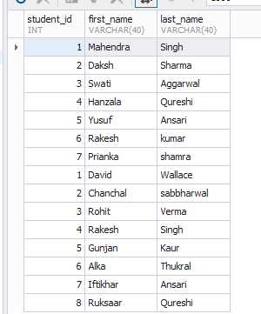

select * FROM student CROSS JOIN courses ;

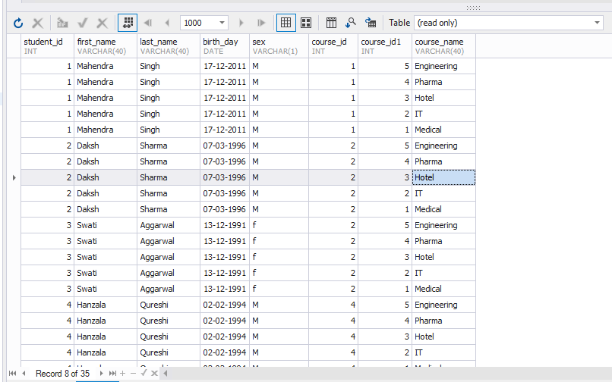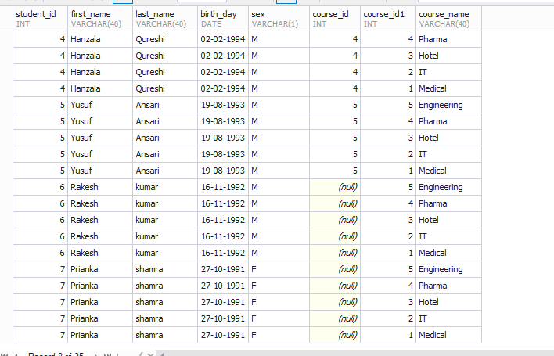

**select * FROM courses CROSS JOIN student ;**

